A Methodology for Validating the Thematic Quality of Decametric Spatial Resolution Leaf Area Index and FAPAR Products using In-Situ Fiducial Reference Measurements

June 11, 2026

Fernandes, Brown, Nickeson, Niro, Tang + all others in alphabetical order

Document Change Record
Iss. | Rev. | Date | Reason | Comments
0 | 0 | October 24, 2025 | Initial draft | Draft outline for CEOS review
0 | 1 | November 13, 2025 | CEOS draft | Draft outline for external review
0 | 2 | June 6, 2026 | Major revision after initial external review. | Scope reduced and methods simplified.
0 | 3 | June 11, 2026 | Improve flow of text up in intro and theory. Added Stage 4 results and removed GPR approach from stage 4. | Finish initial figures for CEOS reviewer to comment.
0 | 4 | October 19, 2026 | Reduce figures and incorporate feedback. | I have still to respond to specific feedback from last set of LPV comments but I have significantly simplified results to make it easier to follow.

Abstract

Leaf Area Index (LAI) and the Fraction of Absorbed Photosynthetically Active Radiation (FAPAR) are biophysical indicators that, respectively, quantify terrestrial vegetation density and potential gross primary productivity.

LAI and FAPAR products at spatial resolution <=250m and temporal resolution <=10d are required by the United National Global Climate Observing System (GCOS). These requirements can now be satisfied using products derived from data acquired by constellations of decametric resolution satellite images. However, GCOS and other users also have thematic quality requirements related to uncertainty and stability. There is currently no globally applicable method for assessing conformity to these requirements. This study presents a methodology for validating conformity of current decametric resolution LAI and FAPAR products with thematic quality requirements for uncertainty and stability in a manner compliant with Committee of Earth Observing Systems (CEOS) good practices.

Joint Council of Guidelines for Metrology (JGCM) protocols, required by the CEOS endorsed Quality Assurance Framework for Earth Observation panel, are used to specify conformity tests for GCOS relative standard uncertainty, defined as the standard deviation of bias corrected residuals divided by the product measurement, and temporal stability, defined as %change in bias/decade, requirements. These tests correspond to comparing the confidence interval of quality statistics estimates using residuals observed between product measurements and in-situ fiducial reference measurements that, for the purpose of this study correspond to, respectively, Simplified Level 2 Prototype Processor products from Landsat and Sentinel 2 data and the Grounded EO reference data. Confidence intervals are estimated for each matchup by weighting robust estimates of residuals at all matchups with a relative inclusion probability that is a function of climate, land cover, and biophysical characteristics of each FRM elementary sampling unit.

Results indicate that when using Landsat inputs, SL2P results in a LAI uncertainty of <1 and FAPR uncertainty of <0.1 and a stability <0.02yr-1, all for a 67.5%ile interval. SL2P estimates using Sentinel 2 inputs result in reduced uncertainty of up to 50%. For the majority of LAI and FAPAR comparisons, the probability of conformity with GCOS threshold requirements is below 0.2 for uncertainty and above 0.5 for stability. The low conformity being due to both retrieval errors and wide confidence intervals for estimates of uncertainty. Global estimates of uncertainty and stability indicates similar patterns as those observed for reference sites but with low representativeness over Africa and central Asia.

Introduction

Leaf area index (LAI) and the fraction of absorbed photosynthetically active radiation (FAPAR) (hereafter collectively LAI/FAPAR) measure terrestrial vegetation density and potential gross primary productivity, respectively (Watson, 1947; Monteith 1972; WMO, 2022) (bold terms are defined in Appendix 1). LAI/FAPAR are essential agriculture, biodiversity and climate variables required for vegetation systematic monitoring (Navarro et al., 2017; GEOGLAM 2022; United Nations, 2022; FAO, 2025; WMO, 2025).

LAI/FAPAR thematic data products are routinely generated at synoptic and global extents using fundamental data records (FDRs) from satellite optical imagers, synthetic aperture radar (SAR) imagers and light detection and ranging (LiDAR) instruments

(Fernandes et al., 2014; Campos-Taberner et al., 2017; CEOS, 2018; Fang et al., 2019a; Dubayah et al., 2020).

The Committee on Earth Observation Satellites (CEOS), tasked by the United Nations Global Climate Observing System (GCOS) (CEOS, 2018), develops validation methods for these products using the Quality Assurance Framework for Earth Observation (QA4EO) (https://qa4eo.org/documents/#guidelines). QA4EO defines validation as "verification, where the specified requirements are adequate for an intended use" (JGCM, 2021) . This definition requires quantifying product quality and testing conformity with user requirements.

GCOS User Requirements for LAI/FAPAR Products

GCOS specifies temporal, spatial, and thematic requirements for estimating LAI and FAPAR (i.e., the measurands) at threshold (minimum usability requirements) , breakthrough (performance sufficient for specific applications) , and goal levels (performance that meets all foreseeable user needs) (Table 1; WMO, 2025).

Table 1. GCOS threshold, breakthrough, and goal user requirements for LAI/FAPAR products.
Requirement | Units | LAI |  |  | FAPAR
Requirement | Units | threshold | breakthrough | goal | threshold | breakthrough | goal
Horizontal  Resolution | m | 250 | 100 | 10 | 250 | 250 | 10
Temporal  Resolution | d | 10 | 10 | 1 | 10 | 10 | 1
Timeliness | d | 10 | 5 | 1 | 10 | 5 | 1
Relative Standard Uncertainty | % | 10 | 10 | 5 | 5 | 5 | 2.5
Minimum Standard Uncertainty | 1 | 0.05 | 0.05 | 0.025 | 0.0025 | 0.0025 | 0.00125
Stability | %/year | 6 | 6 | 3 | 3 | 3 | 1

Horizontal and temporal resolution requirements jointly specify the minimum mapping unit (MMU) that satisfies user requirements. Methods for validating resolution and timeliness requirements are beyond the scope of this study. That said, temporal resolution requirements can be validated by assessing the frequency of LAI/FAPAR estimates for a given mapping unit (e.g., Fuster et al., 2020; Verger et al., 2025). Horizontal resolution requirements are generally met by products derived from decametric-resolution FDRs (Gascon et al., 2017; Gaudel et al., 2017; Ju et al., 2025). Timeliness depends on mission-specific data acquisition and processing infrastructure and must therefore be validated on a case-by-case basis through system-level testing.

Thematic Quality Requirements

This study presents methods for validating product thematic quality requirements for standard uncertainty, relative standard uncertainty, and stability using Joint Committee for Guides in Metrology (JGCM) definitions adopted by QA4EO (JGCM, 2021):
- Uncertainty: A parameter characterizing the dispersion of values attributed to a measurand after bias correction.
- Standard Uncertainty: Standard deviation of attributed values with respect to a reference value.
- Relative Standard Uncertainty: Standard uncertainty divided by the measured value.

The study also presents methods for quantifying stability as defined by GCOS (2025) as:
- Stability: The change in bias, “an estimate of systematic error”, per decade; where error is defined as” the measured value minus a reference value”.

GCOS does not specify requirements for accuracy, defined as “the closeness of agreement between a measurement result and a reference value of a measurand”(JGCM, 2021). However, observing systems frequently specify requirements for relative standard accuracy, defined as the standard deviation of residuals, defined as differences between a product measurement (y) and reference values, divided by the product measurement (Malenovský et al., 2012; Defourny et al., 2019; Chabrillat et al., 2022; Stavros et al., 2023). Relative standard accuracy requirements can be validated when the reference value is a conventional value, a value established by agreement and assumed to represent the true value of the measurand (e.g., zero LAI or FAPAR for non-vegetated surfaces). Otherwise, accuracy cannot be quantified without prior assumptions because the uncertainty of the reference value, itself derived from measurements, is unknown. This limitation has led to the use of the adjective “apparent” to describe errors and accuracy estimates derived using measured reference values (Widlowski, 2015). Neither QA4EO nor JGCM guidelines use the adjective “apparent”. Rather than introducing additional terminology, accuracy requirements can be validated using statistics derived from a set of residuals together with a coverage interval, “an interval containing the validated quantity (e.g., accuracy) with a stated probability based on the information available” (JGCM, 2021).

CEOS Validation Hierarchy

The CEOS Land Product Validation subgroup defines four validation stages (paraphrased in Table 2 using QA4EO terms). This study addresses methods for Stage 4 validation of decametric-resolution LAI/FAPAR products. Stage 4 requires Type A validation (JGCM, 2021), where conformity is tested using thematic quality statistics (hereafter statistics) derived from on comparisons of product measurements with fiducial reference measurements (FRM, y), defined as “a suite of independent, fully characterised, and traceable sub-orbital measurements that follow the guidelines outlined by the GEO/CEOS Quality Assurance framework for Earth Observation (QA4EO) and have value for space-based observations.” ( QA4EO website: http://qa4eo.org/; CEOS, 2025).

Table 2. CEOS Validation Stages.
Level | Definition
0 | No validation. Product thematic quality has not been assessed. Product considered beta.
1 | Product thematic quality is validated with respect to user requirements for a small (typically < 30) set of locations and time periods by comparison with in situ or other suitable reference data.
2 | Product thematic quality is validated with respect to user requirements over a significant (typically > 30) set of locations and time periods by comparison with reference in situ or other suitable reference data.  Spatial and temporal consistency of the product, and its consistency with similar products, has been evaluated over globally representative locations and time periods.  Results are published in the peer-reviewed literature.
3 | Product thematic quality is validated with respect to user requirements over a significant (typically > 30) set of locations and time periods representing global conditions by comparison with reference in situ or other suitable reference data. Validation procedures follow community-agreed-upon good practices.  Spatial and temporal consistency of the product, and its consistency with similar products, has been evaluated over globally representative locations and time periods.  Results are published in the peer-reviewed literature.
4 | Validation results for stage 3 are systematically updated when new product versions are released or as the interannual time series expands.  When appropriate for the product, product thematic quality is validated with respect to user requirements using fiducial reference measurements over a global network of sites and time periods (if available).

Limitations of Current Approaches

LAI/FAPAR products have currently only achieved Stage 3 validation according to CEOS (https://lpvs.gsfc.nasa.gov/Biophys/Biophys_home.html) limited to testing conformity of uncertainty and stability requirements for broad land cover classes (e.g., Berger et al., 2012; Fernandes et al., 2014; Fang et al. 2019). This approach can produce misleading tests of conformity because of i) biased sampling of measurement conditions, corresponding to the measurand and associated influence quantities, defined as quantity that does not affect the quantity being measured but that affects the measurement result (JGCM, 2021), and ii) heteroskedastic residuals between product measurements and reference measurements.

Biased sampling can result in non-negligible differences in validation statistics for the same product over the same land cover. For example, the reported accuracy of Sentinel-2 LAI products generated with the Simplified Level 2 Prototype Processor (SL2P) algorithm for 42 deciduous broadleaf forest (DBF) elementary sampling units (ESUs, ), spatiotemporal intervals associated with a reference measurement ) within the US National Ecological Observatory Network (NEON) was 1.18 ± 0.03 for 203 matchups (Fernandes et al., 2023), dropped to 0.94 ± 0.05 for 500 matchups (Fernandes et al., 2024), and later increased to 1.43 ± 0.08 when the sample size increased to 832 matchups (Brown et al., 2025). This variation indicates that the validation statistic depends strongly on the sampled measurement conditions rather than solely on the nominal land-cover class.

Heteroskedastic residuals as a function of measurement value can also lead to biased validation statistics. For example, Fernandes et al., (2024) showed that stratification by both land cover and reference LAI resulted in an RMSE (reported there as “uncertainty”) ranging from 0.5 to 3 in comparison to an RMSE of 0.91 when stratified by land cover alone. In general, land cover stratification alone cannot provide reliable estimates of uncertainty because uncertainty is defined after removal of measurement bias, and bias in LAI and FAPAR is expected to vary systematically with the reference value. Thus, meaningful estimates of thematic quality require validation statistics to be conditioned on measurement conditions that account for systematic variation in both error and residual variance.

Current CEOS good practice improves the representativeness of thematic quality statistics by conditioning them on the reference measurement, thereby reducing the range of conditions represented within each statistic and enabling bias correction (Fernandes et al., 2014). Both histogram-based estimators (Fuster et al., 2020) and weighted polynomial regression estimators (Fernandes et al., 2024) have been applied for this purpose; the latter increasing statistical efficiency by avoiding binning (Nobel, 1996). Both estimators reduce the sensitivity of thematic quality statistics to the sampled conditions, enabling comparisons between products from different algorithms and input FDRs (Fernandes et al., 2024). However, such statistics assume influence quantity conditions are fully characterized by the reference measurement. However, influence quantities such as canopy clumping, woody cover, canopy optical properties, and FDR measurement error are not necessarily correlated with the measureand (Fang et al., 2019). Moreover, even when sampling encompasses these factors, conformity tests based on population statistics may ne misleading when applied to individual product measurements due to heteroskedastic errors.

Camacho et al. (2025) quantified the conformity of individual Sentinel-3 OLCI FAPAR product measurements with Copernicus Global Land Service accuracy requirements by accounting for both reference and product uncertainty for matchups with upscaled FRM. However, their approach has limitations for validating decametric-resolution LAI/FAPAR products against GCOS requirements within the CEOS framework:
- Uncertainty Evaluation: They relied on producer-provided Type B estimates with FRM comparisons as required by CEOS.
- Temporal Matching: They only estimated statistics based for exact temporal matches between FRM and product measurements, limiting the Stage 4 validation to locations with ongoing FRM.
- Stability. Stability was not assessed.

Research Questions

This study defines and demonstrates a methodology for CEOS Stage 3 and Stage 4 validation of decametric-resolution LAI/FAPAR products. Two research questions are addressed:
- Validation: How can conformity be quantified for product estimates lacking corresponding reference measurements?
- Intercomparison: How can conformity tests be compared across algorithms utilizing different matchups?

The paper is structured as follows: Section 1 outlines the theoretical framework based on CEOS protocols and QA4EO guidelines. Section 2 describes a globally representative LAI/FAPAR algorithm dataset and its FRMs. Section 3 applies the framework to validate GCOS requirements for Stage 3 (observed errors) and Stage 4 (global estimates). Section 4 discusses strengths, limitations, and broader applicability, and Section 5 concludes by answering the research questions.

Theory

2.1 User Requirement Specification

In the context of satellite product validation, a user requirement specification defines:
- Measurands (y): Particular quantities subject to measurement (e.g., LAI/FAPAR).
- Parameters (x),: Characteristics associated with y other than y itself used to quantify influence quantities.
- Tolerance limits: intervals of limiting values that separate intervals of permissible values of the measurand from intervals of non-permissible values.

2.2.1 Measurands
LAI and FAPAR measurands must be defined in the user requirement specification. These definitions will have associated definitional uncertainty— arising from the finite specificity of a measurand definition. GCOS definitions are ambiguous under some conditions due to natural variability within ecosystems (Table 3). For example, GCOS does not clearly define the condition “green” with respect to LAI or the adjective “effectively” with respect to FAPAR. CEOS has published proposed clarifications of the GCOS definitions that identify excluded conditions and highlight known sources of uncertainty for which community consensus on quantification has not yet been achieved (Table 3; Fernandes et al., 2025a,b). Definitional uncertainty can be quantified using expert consensus or numerical simulations (JGCM calls this Type B uncertainty quantification) and incorporated in conformity tests. The validation method presented here assumes definitional uncertainty is negligible compared to product uncertainty.
Table 3. GCOS definition of LAI/FAPAR measurands (WMO, 2025) with conditions specified by CEOS (Fernandes et al., 2024a,b)
Measurand | Leaf Area Index | Fraction of Absorbed Photosynthetically  Active Radiation
Abbreviation | LAI | FAPAR
SI Symbol | None | None
SI Units¹ | 1 | 1
Definition | half the total green leaf area per unit horizontal ground area | the fraction of incoming solar radiation in the 400–700 nm spectral range that is absorbed by green elements of plants for photosynthesis
Exclusion Conditions | nonvascular organs (miss, bryophytes, green stems). Green leaves below the ground or water surface. | Plants below the ground or water surface.
Unspecified sources of uncertainty. | Definition of “green” | Definition of “green” and “effectively”  Incoming solar radiation field. Adjectives include:  Direct: direct solar illumination  Diffuse: isotropic over lower hemisphere downwelling solar radiation  Ambient: ambient downwelling solar radiation field
¹The System International dimensions of LAI and FAPAR units is “1” and are omitted (Thompson and Taylor, 2008).

Parameters

Type A validation must associate each measurement condition with statistics derived from residuals based on a set of observed matchups y,y with the same or at least similar condition. Furthermore, the condition must be repeatable, in that residuals share influence quantities that “typically includes measurement procedure, measuring system, measuring system operator, operating conditions, and measurement location held fixed while performing two or more measurements over a period of time … as short as necessary in order to avoid the occurrence of changes in the set of conditions” JGCM (2021). Numerous parameters correspond to influence quantities for LAI/fAPAR measurements from optical imagers (Fang et al., 2019a) but only a limited number are observed routinely coincident with ESUs with in-situ measurements and even fewer are available for the mapping unit corresponding to arbitrary product measurements (Table 4).

Table 4. Parameters used to model inclusion probability for uncertainty (all rows) and bias (only shaded rows). Parameters in bold are only available in-situ at matchup locations.
Variable | xi | θi | Purpose
Land cover | Copernicus Global Land Cover | Assumed negligible | Errors due to foliage and soil optical properties and foliage vertical distribution.
LAI PM | Product LAI | LAI Uncertainty | Errors due to signal saturation and understory
FAPAR PM | Product FAPAR | FAPAR Uncertainty | Errors due to signal saturation and understory
LAI PM standard deviation | Product LAI standard deviation within validation MMU | Range of standard deviation over homogenous sites. | Spatial heterogeneity
FAPAR PM standard deviation | Product FAPAR standard deviation within validation MMU | Range of standard deviation over homogenous sites. | Spatial heterogeneity
LAI Uncertainty | Product LAI uncertainty | Product ATBD | Errors due to sensor measurement
FAPAR Uncertainty | Product FAPAR Uncertainty | Product ATBD | Errors due to sensor measurement
Annual Growing Degree Days | ERA 5 1km daily | Half total range over each site | Growing season length
Number of Days with rooting zone soil T above zero | ERA 5 1km daily | Half total range over each site | Growing season length
Annual PET/Annual P | ERA 5 1km daily | Half total range over each site | Aridity
LAI FRM | FRM LAI | FRM LAI uncertainty | Errors due to saturation or exposed soils
FAPAR FRM | FRM FAPAR | FRM FAPAR uncertainty | Errors due to saturation or exposed soils
Clumping index | FRM clumping index | FRM clumping index uncertainty | Errors due to canopy structure
Woody area index | FRM woody area index | FRM woody area index uncertainty | Errors due to optical properties

2.1.3 Tolerance Interval

GCOS requirements specify tolerance intervals for horizontal resolution, temporal resolution, uncertainty, and stability, which must be simultaneously satisfied for a measurement to be considered conforming. GCOS does not explicitly specify tolerance intervals for accuracy. Here, accuracy tolerance intervals can conservatively be taken as equivalent to those for uncertainty, because accuracy reflects both random and systematic errors.

GCOS horizontal and temporal resolution requirements constrain the spatial and temporal extent of matchups over which errors between product and reference measurements are quantified. Matchup extent must be at least as fine as the required horizontal and temporal resolution. Matchups may contain multiple associated product and reference measurements, with gaps caused by missing FDR observations or invalid retrievals. Although each associated measurement samples the matchup conditions, their spatial and temporal representativeness may vary. For example, product observations over an agricultural field may span pre- and post-harvest conditions, while the reference measurement may represent only one of these states. Similarly, a measurement footprint may extend beyond the matchup because of the measurement approach or geolocation errors. Methods are therefore required to maximize the likelihood that reference measurements

2.2 Type of Validation Adopted

Type A estimates of uncertainty and bias require residuals observed under repeatable conditions. For instruments such as chronometers, parameters relevant to measurement conditions can be identified using physical models and can be controlled to sufficient extent during matchups. In contrast, , however, measurement conditions for satellite-derived LAI/FAPAR products can realistically be assumed to be identical only when product and reference measurements sample the same location and time. This assumption is often violated for decametric-resolution LAI/FAPAR products because independent product and reference measurements of the same land-surface conditions within the required temporal window (e.g., 10 days) are rare. Moreover, restricting matchups to locations with multiple measurements would limit the range of conditions that can be validated and could violate the standard uncertainty assumption of independent sampling.

Instead, matchups used to estimate validation statistics for the conditions associated with a given product measurement are assumed to be independent samples from a sampling distribution of possible matchups that share the same sources of error and associated error pdf. The inclusion probability (pi,j) is defined as the probability that the jth matchup shares the repeatability condition of the ith product measurement. This probability is assumed to be described by a prior distribution conditioned on parameters and defines which matchups can be considered samples from the same measurement conditions. This is a Type B assumption, following JGCM nomenclature, as it makes a prior assumption regarding distributions of conditions, that enables the Type A estimation of LAI/FAPAR product uncertainty and bias required by CEOS.

Because prior assumptions are used to model pi,j, pure Type A validation based on the observed frequency distribution of errors is replaced by sampling from a probability distribution of matchups. The validation exercise therefore becomes a statistical experiment (Box et al., 2005). Statistical experiments comprise three components that structure the remainder of this study (Stehman and Czaplewski, 1998; Tyukavina et al., 2025):
- Sampling design: the “protocol by which the reference sample units are selected.”
- Response design: “all the steps that lead to a decision regarding the agreement between individual RM and product measurements.”
- Analysis: the procedures used to estimate validation statistics from observed differences at matchups, accounting for their associated uncertainties, and to report these estimates so that users can determine whether products meet requirements at a stated level of confidence.
The application of these three components to the validation of decametric-resolution LAI/FAPAR products is detailed in the following sections.

2.3 Sampling Design

Normally, a validation sampling design optimizes matchups location and timing to maximize the representativeness and sample independence, while satisfying constraints such as randomization and resources for FRM (Stehman, xx). Current LAI/FAPAR FRM datasets are based either on manual surveys that provide measurements at multiple locations over limited periods or on fixed automated sensors that provide high-temporal-resolution observations over longer periods at limited spatial locations (Fang et al., 2019; Brown et al., 2021). Available matchups can instead be interpreted as arising from as a non-optimal sampling design that is:
- (i) Stratified by land-cover class, and climate;
- (ii) Spatially separated to ensure approximate independence; and
- (iii) Representative of random sampling, since valid product retrieval timing is generally independent of in-situ measurement errors.

2.3.1 Modeling Inclusion Probabilities

Assuming independent random sampling, matchups within a stratum represent a common distribution of measurement conditions. Because exact replicability conditions for an arbitrary product measurement are unlikely, we use expert judgement (Type B) to model pi,jas an uncorrelated multivariate Normal probability density function (pdf) for parameters xj of the jth measurement, with mean defined as the xi of the ith matchup with variance vector θi is specified using expert knowledge and modelling studies of the sources of error (Table xx):

pxjxi=Nxjxi,θi (1)

An uncorrelated distribution is used to reduce the sensitivity of pi,j to parameter measurement error and due to insufficient knowledge regarding the influence of covarying parameters . Inclusion probabilities for measurements without in-situ information are denoted pxjxi.

This approach to modelling inclusion probability assumes residuals observed for xi can be observed for conditions xj with non-zero probability. This is not always the case as, for example, for a product algorithm that limits measurement estimates of LAI between 0 and 10, the residual for a ESU where the reference LAI is 5 may never exceed 5. To increase the likelihood that inclusion probabilities are representative of the similarity of conditions between two measurements we set pxjxi=0 if it falls below a minimum level pmin. A practical lower bound on pmin corresponds to the minimum of inclusion probabilities observed for conditions in the same site:
pmin=min∀i,jsiteinfpxjxi,pxjxi (2)

2.4 Response Design

The response design defines how residuals are estimated for a matchup. While previous validation practices focused on hectometric LAI/FAPAR products with single coincident measurements, decametric-resolution products often feature finer spatial resolutions and temporal sampling that may not exactly match reference measurement times (Fernandes et al., 2014; Brown et al., xx; Camacho et al., xx).

Although direct comparisons between product measurements and FRM may reduce spatial scaling uncertainties, heterogeneous landscapes can introduce rapid temporal disturbances or spatial variability that may bias validation statistics. Sample specific estimates of measurement footprint and high-resolution ancillary data (e.g. Brown et al., 2020; Lanconelli et al., 2024;) is rarely feasible or consistently documented across networks. Instead, we use robust estimators of the expected value of residuals between FRM and product measurements within a matchup.

2.4.1 FRM Estimate

For a matchup y,y within an ESU for day d , the FRM expected value ( yd) and standard errors ( σd) is estimated as:

yd= yi ∈ ywi yi (3)
σd=1 yi ∈ ywi (4)
where, given the standard uncertainty for each yi ( σi):
wi=1σi2 (5)

2.4.2 Daily Error Calculation
The residual between any measurement yi and a FRM is defined as:
ri,d=yi- yd (6)

with uncertainty corresponding to the Euclidean sum of σd and a prior estimate of measurement uncertainty ( σi)required for CEOS Analysis Ready Data compliant products
σr=σi2+σd2 (7)
The residual between y and yd for day d (ed) is estimated using a weighted median of differences:

ed=MdnW∀iri,d,wi (8)
With
wi=1σr (9)
The weighted median difference is used rather than the weighted mean to reduce the influence of geolocation and temporal mismatches and within ESU heterogeneity on ed. The standard error of ed (sed2) due to finite sampling is estimated as the half-width of the 67.5% confidence interval of the weighted median (Allouche and Gobet, 2025) with effective number of degrees of freedom:
ni=i=1nwi2i=1nwi2 (10)

The additional uncertainty in ed due to σr(sr) is:
sr=σrni (11)

2.4.3 Temporal Aggregation and Total Error

To minimize the impact of geolocation errors and residual image artifacts (e.g. atmospheric effects , shadows) the error for time interval T (e) is estimated as the minimum daily error:

eT =mind∈Ted (12)

Assuming ed values are outliers-free, the standard error of ed due to temporal variability (sT) is modelled assuming the range of ed within T corresponds an uncertainty interval of +/-2 standard deviations:

sT=maxd∈Ted-mind∈Ted4 (13)

The standard error of eT (seT) is estimated as the Euclidean sum of the sample median standard error and the temporal variability standard error:
seT=sr2+sed2+σT2 (14)

2.5 Analysis Design

The analysis design tests product conformity with user requirements using thematic quality statistics derived from observed errors, standard uncertainties, and matchup parameters. Validating GCOS thematic quality requirements requires quantifying relative standard uncertainty, standard uncertainty, and stability statistics. These statistics require an explicit estimate of bias: stability evaluates changes in bias over time, while uncertainty requires subtracting bias from errors if it is non-negligible compared to uncertainty (JCGM, 2021).

2.5.1 Bias

Bias is the expected error of yi . The bias for the ith measurement (bi) is estimated using the weighted median of errors across all matchups as long as the median inclusion probability exceeds some threshold :

bi=MdnW∀j=1…nej,wi,jMax∀j=1…n pxjxi>pminundefinedelse (15)

where the weights wi,j account for both the inclusion probability and the standard uncertainty of the estimated error for each matchup:

wi,j=1j=1n pxjxiσej2 pxjxiσej2 (16)

Here, pmin is the lower bound on the maximum pxjxi between the conditions at matchup I and all other matchups j (pmax) that acts to censor any statistics for measurements with conditions not represented by at least one matchup.

The one standard deviation confidence interval of bi (σbi) is estimated as the Euclidean sum of the uncertainty in the estimate of the weighted median (σbi ) and the ucnertanity due to the use of p rather than p when estimating bias (δbi ), and the standard error in estimating errors (sei)

σbi=σbi2+δbi2+sei2) (17)

Where:
σbi is estimated as the half width of the 67.5%ile confidence interval of the weighted median(σbi ) sites (Allouche and Gobet, 2025) ,

and δbi is estimated as:

δbi =MdnWj=1…nbj-bj,wi,jminj=1…n pxjxi>pminundefinedelse (18)

where bj is derived usnig Equation xx replacing p with p ,

The use of a weighted median estimator for bi complicates the estimate of sei . Here we assume the weighted median of uncertainties in errors is appropriate to estimate the uncertainty due to a single observed error:

sei =MdnW∀j=1…nseT,wi,jniMax∀j=1…n pxjxi>pminundefinedelse (19)

2.5.2 Standard Uncertainty

The standard uncertainty of of yi is estimated as the weighted median absolute deviation of bias corrected errors observed for all n matchups adjusted for reference measurement standard error:

ui=1.4826MdnWj=1…nej-bj,wi,j2-syi2Max∀j=1…n pxjxi>pminundefinedelse (20)

The weighted median absolute deviation is multiplied by 1.4826 to approximate the standard deviation under the assumption of a normal distribution (Kendall and Stuart, xx)

The one standard deviation confidence interval of ui (σui) is estimated as the euclidean sum of the uncertainty in the estimate of the weighted median (σui ) and the ucnertanity due to the use of p rather than p when estimating bias (δui ) and the uncertainty due to the uncertainties both ej and bj (sej-bj)

σui=σui2+δui2+sej-bj2 (21)
Where σui was estimated as the Euclidean sum of the numerically determined 67.5% confidence interval of the weighted median of errors and the weighted average uncertainty of the reference measurements:

σui =1.4826 φi2+1j=1npxjxij=1npxjxisej2 (22)

and δui was estimated as

δui =MdnWj=1…nuj-uj,wi,jMax∀j=1…n pxjxi>pminundefinedelse (23)

Where uj is derived using Equation xx replacing p with p

As for bias, we estimate sej-bj using the formula for the uncertainty of the weighted average rather than weighted median in Equation 23 but approximating the weighted average using a weighted median weighted uncertainty of each difference ej-bj:

sej-bj =1.48MdnW∀j=1…nsej2+sbj2,wi,j2ujniMax∀j=1…n pxjxi>pminundefinedelse (240

2.5.3 Relative Standard Uncertainty

The relative standard uncertainty of the ith measurement is estimated is estimated as

ur,i=uiyi (25)

The one standard deviation confidence interval of ur,i (σur,i) is estimated as:

σur,i=ur,iσuiui2+syiyi2 (26)

2.5.4 Stability

Stability requires quantifying the change in bias between two years (Yk,Yl) for a matchup condition , excluding instrument-related influence quantities. While measurement stability is often characterized under controlled conditions (e.g., Pai et al., 2015), this is generally unfeasible for the wide range of conditions experienced by LAI/FAPAR products over multiple years.

Instead, the bias at the ith measurement is estimated for any year Y (biY) by setting pxjxi=0 if Yj≠Yi . The stability for the ith measurement is then estimated as the weighted median of stability for all pairwise combinations Yk,Yl,

s=MdnWk≠lsk,l,ωk,l (27)

sk,l=biYl-biYkbiYk×Yl-Yk (28)

where the weight ωk,l, is inversely proportional to the squared standard uncertainty of sk,l, σk,l:
σk,l=bYlbYk σbYlbYl2+σbYkbYk2 (29)

2.5.5 Conformity Testing

Conformity testing labels matchups as satisfying user requirements with a specified probability, requiring two conditions to be met:

- Representativeness: The statistic must be representative of the measurement. The representativeness of a statistic associated with a measurement is quantified as the maximum inclusion probability with an interval of uncertainty for this estimate based on the standard deviation of the sensitivity of inclusion probabilities to the absence of in-situ information.

- Conformity probability: The probability of conformity must fall within established tolerance intervals. The probability of conformity falling within tolerance intervals is quantified as the cumulative probability the estimated product measurement and associated validation statistics (e.g. standard uncertainty, stability) fall within user requirements (e.g. threshold requirements) (JGCM, 2012). Here, the probability is modelled assuming truncated uncorrelated bivariate normal distribution for the product measurement and the associated validate statistic (standard uncertainty, stability) with standard deviations specified by the product measurement standard uncertainty and the validation statistic standard uncertainty (e.g. Figure 1).

- 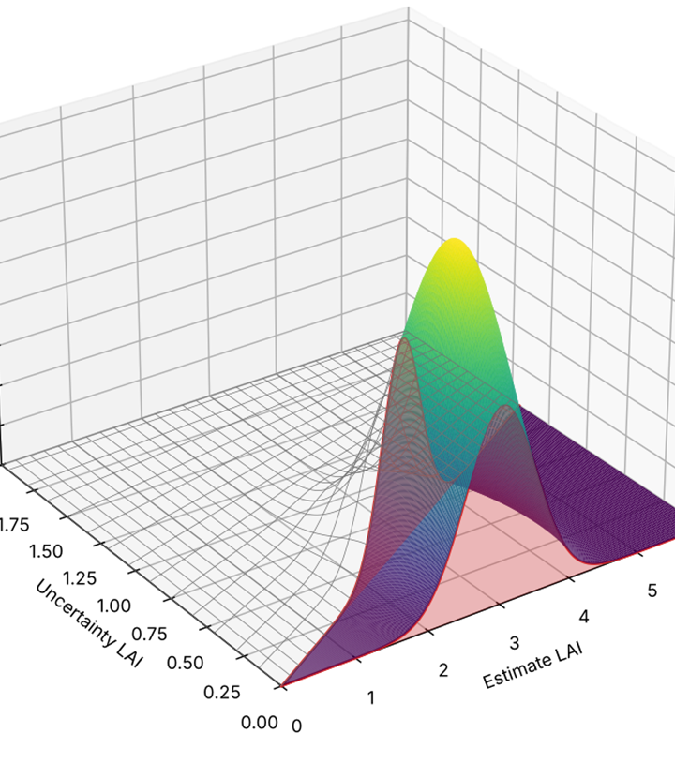
Figure 1. Estimating the probability of conforming with LAI uncertainty requirements for a measurement (LAI 3 , standard uncertainty 0.5, and one standard distribution confidence interval for the uncertainty estimate of 0.3) as the probability mass of the estimated statistics (here uncertainty LAI) satisfying user requirements.

Materials

3.1 In-Situ Fiducial Reference Measurements

3.1.1 Dataset and Study Sites

The GROUNDED EO database (Brown et al., 2025), comprising 9,382 paired LAI/FAPAR estimates from 1,087 ESUs across 71 sites in Australia (TERN), Europe (ICOS), and the United States (NEON) comprise the FRM used here (Figure 1). Sites are stratified by ecological diversity within each network. Sites included land cover using the National Land Cover Database (NLCD) legend woody area index (WAI), and canopy clumping index surveyed using methods ( Brown et al. 2025) that enable fiducial reference measurements of LAI and FAPAR with uncertainties traceable to community standards (Brown et al., 2021a).

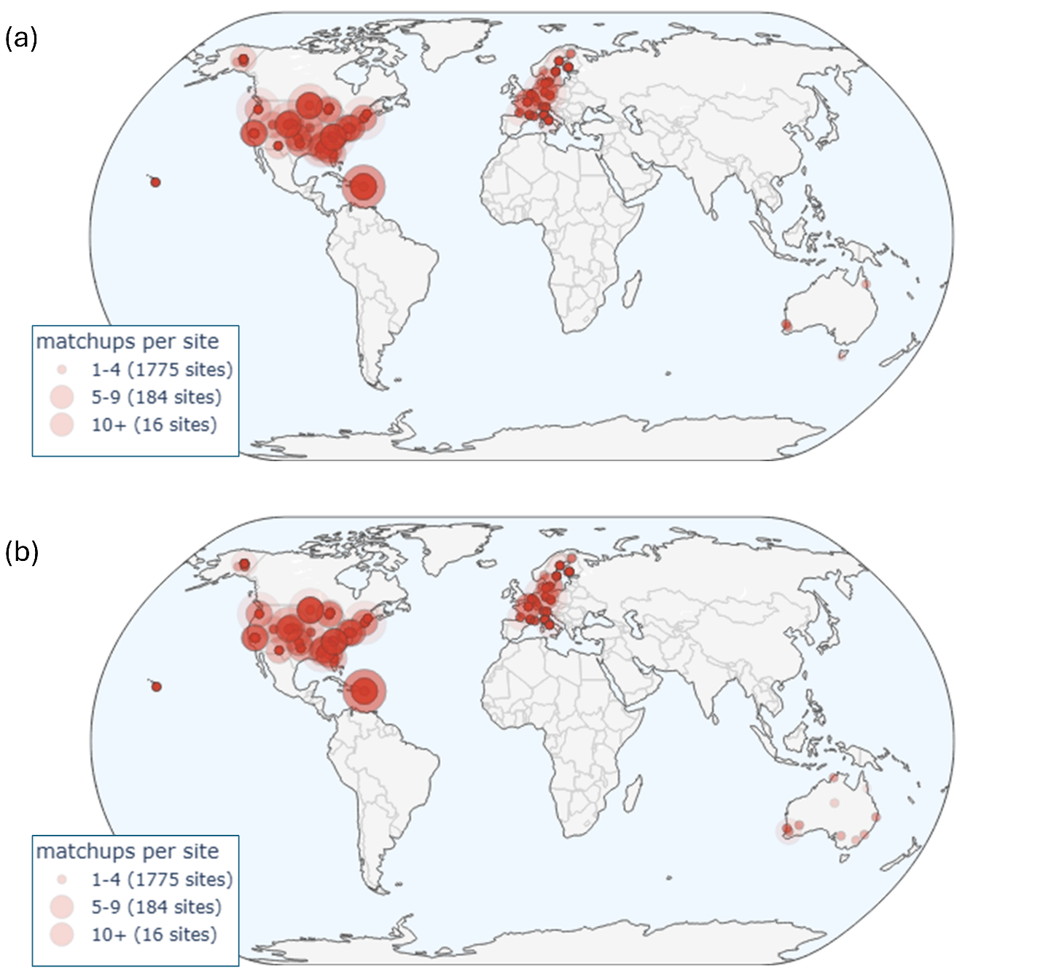
Figure 2. Number of matchups per GroundedEO site for (a) HLS L30 fundamental data records and (b) HLS S30 fundamental data records.

3.1.2 Data Quality and WAI Correction

Exploratory data analysis identified 62 ESUs across seven forest sites with unrealistically low WAI values (Supplementary Material 1) corresponding to land cover default values from Brown et al. (2021b) rather than plot-specific measurements. These values were replaced with linear regression estimates of WAI as a function of PAI, calibrated using paired WAI and PAI measurements from all other sites with the same land-cover type. The uncertainty of the affected LAI estimates was revised by substituting the nominal WAI standard uncertainty with the one-standard-deviation regression prediction confidence interval.

3.1.3 Spatial Heterogeneity Assessment

ESUs were visually assessed for spatial heterogeneity of land cover and fraction of vegetation cover using the most recent high resolution ESRI World Imagery and Google Earth Pro imagery available (e.g. Figure 2). Sites were qualitatively classified into three categories:
- Homogeneous within a 60 m radius of the ESU centroid;
- Homogeneous within a 30 m radius, but heterogeneous between 30 m and 60 m.
- Heterogeneous within a 30 m radius; or
The 30 m radius approximates the spatial support of the in-situ measurements. The 60 m radius encompasses a 3×3 patch of nominal 30 m Harmonized Landsat and Sentinel-2 (HLS) pixels, accommodating worst-case geolocation errors (see Section 3.3).

Table 5. Description of in-situ FRM networks. Values in brackets correspond to cases that include at least 1 matchup.
 | Network
 | ICOS | NEON | TERN
Spatial Extent | European Union, UK | United States of America | Australia
Start Date | 2017 | 2013 | 2011
End Date | 2022 | 2022 | 2023
#Sites | 20 (20) | 47 (45) | 14 (14)
#ESUs | 420 (324) | 947 (821) | 21 (19)
#FRM | 1776 (1442) | 11464 (10013) | 154 (146)
#ESUs intraannual | 54 (44) | 144 (121) | 4 (4)

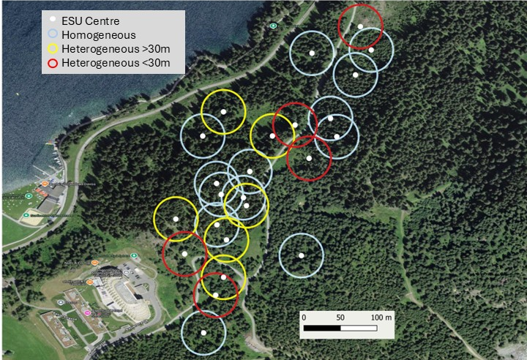
Figure 3. Visually assessed ESU spatial heterogeneity at the Davos ICOS site. ESU centres indicated by solid white circles. Hollow circles indicate 30m radius neighbourhood around each ESU.

3.2 Land cover

The10m resolution circa 2020 ESA WorldCover 10m v200 (Zanga et al., 2021) was used to specify other vegetation, non-vegetation, and forest land cover groups. The forest land cover group was subdivided into broadleaf and needle leaf forests using the 30m resolution Land Cover of North America NALCMS 2020 (Commission for Environmental Cooperation, 2023) over North America and, the 2019 100m resolution Copernicus Global Land Cover Layers: CGLS-LC100 Collection 3 (Buchhorn et al., 2020 ) elsewhere (Table 6).

Table 6 Land cover group definition.
WorldCover | NALCMS 2020 | CGLS LC100 | NLCD Class | Group
Tree cover | Temperate or sub-polar needleleaf forest  Sub-polar taiga needleleaf forest | Closed forest, evergreen needle leaf.  Closed forest, deciduous needle leaf  Open forest, evergreen needle leaf.  Open forest, deciduous needle leaf. | Evergreen forest  Mixed Forest | NF
Tree cover | Not needle leaf classes | Not need leaf classes | Deciduous Forest  Woody wetlands | BF
Shrubland |  |  | Shrub Scrub | OV
Grassland |  |  | Grassland/Herbaceous  Pasture/hay | OV
Cropland |  |  | Cultivated Crops | OV
Built-up |  | Developed | Developed | NV
Bare / sparse vegetation |  | Barren Land | Barren Land  Dwarf Scrub | OV
Snow and ice |  | Perennial snow/ice cover | Perennial snow/ice cover | NV
Permanent water bodies |  | Open water | Open water | NV
Herbaceous wetland |  |  | Sedge Herbaceous  Emergent Herbaceous Wetlands | OV
Mangroves |  |  |  | BF
Moss and lichen |  |  | Lichens  Moss | OV

3.3 Fundamental Data Records

FDRs corresponded to all 30m resolution clear-sky snow and water free land HLS Nadir Bidirectional Reflectance Distribution Function Adjusted Reflectance (NBAR) measurements from the Landsat 8 and 9 OLI from 11/04/2013 onwards from the Google Earth Engine https://developers.google.com/earth-engine/datasets/catalog/NASA_HLS_HLSL30_v002 collection (HLS L30) and Sentinel 2a,b,c Multispectral Instrument from https://developers.google.com/earth-engine/datasets/catalog/NASA_HLS_HLSS30_v002 (HL S30) from 28/11/2015, intersecting ta 60m radius buffer centred on each ESU and also on a global 100km x 100km grid.

Measurements were retained only if the FMASK layer indicated low-aerosol, cloud-free, and cloud-shadow-free conditions. Measurements flagged with snow or water were discarded, as these conditions are excluded from the FRM.

3.4 Product Measurements

LAI and FAPAR were estimated for clear-sky FDRs globally and at matchup locations using all available spectral bands for the input FDRs.

3.4.1 Algorithm Selection: SL2P

While numerous algorithms exist for generating decametric LAI/FAPAR products from systematic FDRs (CEOS, 2025), the Simplified Level 2 Prototype (SL2P) algorithm (Weiss et al., 2020) was selected because it is:
- Independent of FRM.
- Globally applicable to both Landsat 8/9 OLI and Sentinel-2 MSI decametric FDRs;
- Provides associated theoretical uncertainty estimates with each measurement; and
- Avalable as open-source code (Djamai et al., 2024 )

3.4.2 SL2P Architecture and Training

SL2P employs separate sensor-specific, single-hidden-layer neural networks to estimate LAI, FAPAR, and their theoretical uncertainties (uLAI and uFAPAR) using a subset of OLI or MSI surface reflectance bands (Table 3). The networks are trained on a calibration database of 42,748 simulated reflectance spectra, for Landsat 8 OLI spectral bands and sampled randomly across nominal OLI acquisition geometry (for HLS L30 products) or Sentinel 2A MSI spectral bands and sampled randomly across nominal S2A MSI acquisition geometry (for HLS S30 products). Theoretical uncertainties, representing the standard uncertainty of estimates derived from hold-out cross-validation using an independent simulation database, combined with nominal FDR measurement errors, were also estimated for each product measurement.

3.4.3 Simulation and Quality Filtering

Surface conditions for each simulation are drawn via orthogonal sampling from a joint distribution of vegetation structure and optical properties (leaf and soil), fitted to global pre-algorithm in-situ and in-vivo measurements. Reflectance is simulated using the 4SAIL canopy reflectance model and the PROSPECT-D leaf optical model, incorporating additive and multiplicative noise corresponding to nominal sensor uncertainties (see Weiss et al., 2020). SL2P estimates were discarded if the input reflectance does not match at least one calibration sample within 0.05 in each band or the output estimate exceeds the range of the calibration database.

3.5 Climate Data

Gridded daily 1.1312 km resolution ERA5-Land Daily Aggregated - ECMWF Climate Reanalysis (Muñoz Sabater et al., 2021) layers, archived in Google Earth Engine, were sampled to produce annual climate parameters spatially coincident with thematic data products:
- GDD: Total growing degree days above a base temperature of 10°C;
- FROST: Total number of days with a daily minimum soil temperature (0–7 cm depth) greater than 0°C; and
- ARIDITY: Ratio of potential evapotranspiration to precipitation.
The uncertainty for GDD, FROST, and ARIDITY was estimated as their temporal range spanning from 2013 to 2025 inclusive.

4. Results

4.1 Validation

A total of 4245 HLS L30 matchups and 4285 HLS S30 matchups were observed within +/-7d of in-situ measurements and xx HLS L30 matchups and x HLS S30 matchups for a +/-1 d window. Matchups were observed at all sites (Figure 2) although the majority (xx %) were within the continental US due to the longer temporal extent of the NEON FRM network compared to European and Australian networks. For brevity, only HLS L30 validation results for +/-7d matchup intervals across all sites are presented in detail with sensitivity analyses provided to heterogeneity and temporal sampling included in supplementary material (Supplementary Material S2).

As noted in previous validation studies using Grounded EO FRM (Brown et al., 2021b, Fernandes et a., 2024) , matchup land cover was non-uniformly distributed across SL2P estimates of LAI and FAPAR , with high SL2P estimates mainly associated with forest cover (Figure 4). Clumping index and woody area index were also distributed in a non-uniform manner (Figure 4) both because these are generally higher for forests versus other land cover and because the GroundedEO forest FRM were generally for mature forests where clumping index can be higher due to canopy closure and woody area index is also higher due to accumulated standing woody matter over time.

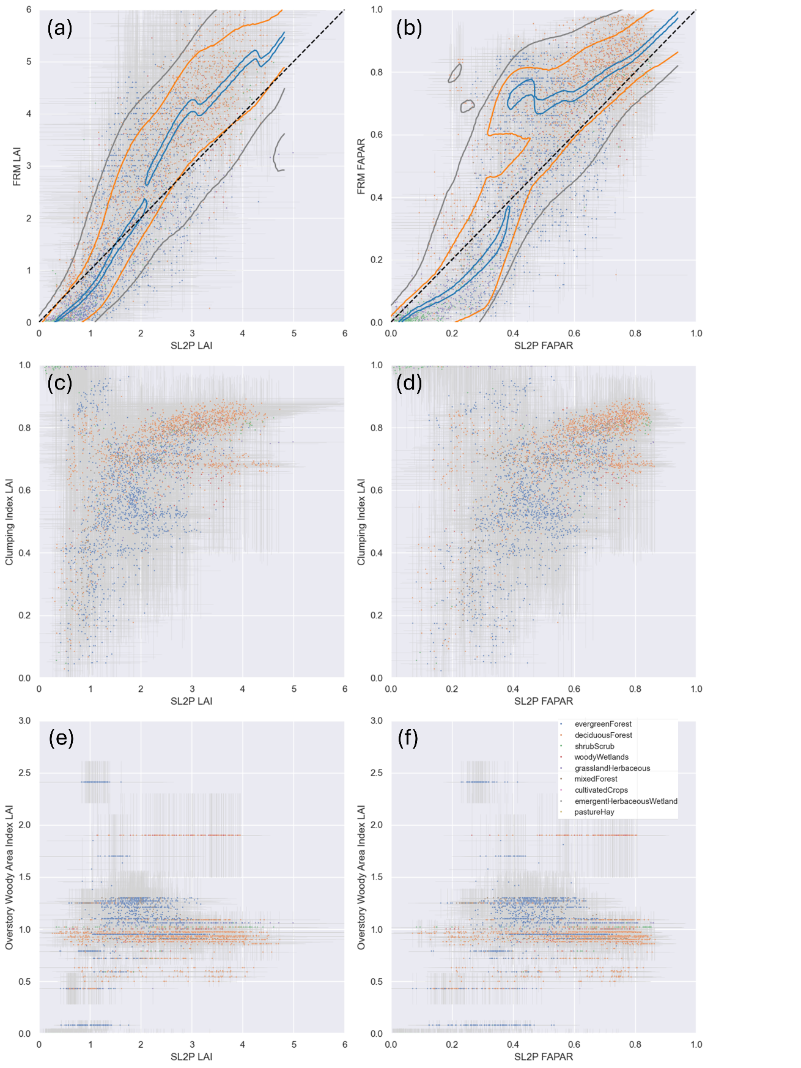
Figure 4. Scatter plot of HLS Estimates for (a) FRM LAI (c ) FRM clumping index, e) FRM woody area index versus SL2P LAI and (b) FRM FAPAR (d ) FRM clumping index, f) FRM woody area index versus SL2P FAPAR, coloured by land cover class. Contours indicate 0.1 (blue),, 0.67 (orange) and 0.90 (grey) cumulative conditional probability of bias given FRM. Whiskers in panels (a) and (b) indicate one standard deviation intervals of estimates or FRM. Common land cover legend included in panel (f).

4.2 Bias

SL2P estimates of LAI showed evidence of overestimation for SL2P LAI <2 and underestimation for SL2P LAI>2 (Figure 5a). Similarly, SL2P estimates for FAPAR showed evidence of overestimation for SL2P FAPAR <0.4 and underestimation for SL2P FAPAR>0.4 (Figure 5b). These biases are not always evident for single matchups or even matchups for a single land cover but are clear from contours of condition marginal distributions of bias given SL2P estimates. These contours also indicate breakpoints where bias changes from underestimation to overestimation. The dispersion of FAPAR bias was generally greater than that of LAI bias both in terms of the width of the interval of conditional bias given the product measurement (e.g. orange contours for 67%ile interval) and the confidence interval of estimated bias (vertical whiskers). Bias correction is generally effective except for FRM FAPAR>0.9 where matchups are limited. (Figure 5d).

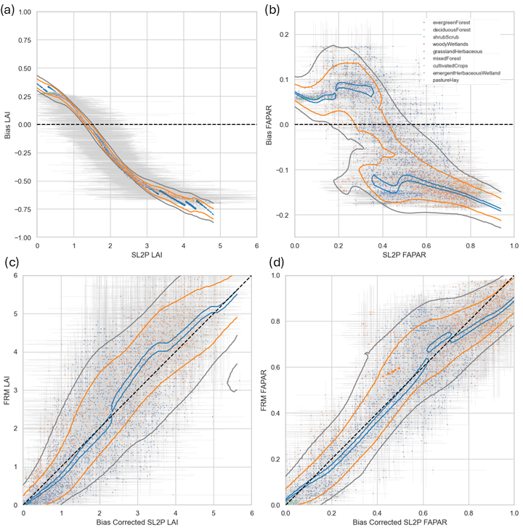
Figure 5. Scatter plots of (a) LAI bias (b) FAPAR bias as a function of S2P LAI and (c) FRM LAI versus bias corrected SL2P LAI and (b) FRM FAPAR versus bias corrected SL2P FAPAR. Contours indicate 0.1 (blue),, 0.67 (orange) and 0.90 (grey) cumulative conditional probability of bias given FRM. . Whiskers indicate one standard deviation intervals of estimates or FRM. Symbol size proportional to clumping index.

4.3 Uncertainty

Conditional distributions of uncertainty given the SL2P estimate are evaluated both because modelling studies suggest uncertainty should increase with increasing LAI and because user requirements correspond to relative standard uncertainties. Uncertainty ranged from 0 to ~2 for LAI and 0 to ~0.2 for FAPAR for individual matchup, with expected values for individual matchups (scatter plot points) exceeding GCOS requirements about half the time for LAI (Figure 6a) and for the majority of FAPAR retrievals (Figure 6c). However, the one standard deviation intervals for individual LAI and FAPAR uncertainty estimates (whiskers in Figure 6a,c) was large, approaching +/-1 LAI and +/-0.2 FAPAR in some cases, and typically of similar magnitude to the range of uncertainty estimates across matchups for a given level of SL2P estimates (grey contours in Figure 6a,c) . As a result, validating or comparing products uncertainty must both account for estimation errors to and consider distributions of estimates across matchups to have useful levels of statistical confidence.

Conditional distributions of uncertainty for LAI (Figure 6a) and FAPAR (Figure 6c) as a function of the SL2P estimate increase for low S2LP estimates (SL2P LAI<2 , SL2P FAPAR<0.3) and level off at and expected value of uncertainty of ~0.5 LAI and ~~0.05 FAPAR, respectively. However, there is significant across matchup variability in uncertainty. For LAI, uncertainty ranged from ~0.25 to ~0.75 for the central 67%ile and from ~0 to ~1 for the 90%ile. The situation for FAPAR is more complicated in that while the lower 67%ile of conditional uncertainty is ~0.025 the upper 67%ile interval includes a mode at SL2P FAPAR 0.5 that with uncertainty exceeding 0.1.

4.4 Stability

Stability estimates for individual matchups ranged from +/-0.02 yr⁻¹ for both LAI (Figure 6b) and FAPAR (Figure 6d) . These estimate fell within GCOS FAPAR requirements even considering the estimation intervals for FAPAR uncertainty (whiskers in Figure 6d). As a result, stability for FAPAR could be evaluated for individual matchups but conditional distributions are considered for consistency between LAI and FAPAR validation methods. Conditional distributions of stability given SL2P estimates indicate LAI stability gets worse (increasing magnitude of the staistics) with increasing LAI, reaching 0.01yr⁻¹ at SL2P LAI 5 but FAPAR stability was essentially constant with SL2P FAPAR. That said, LAI stability did show a mode of poor stability (0.02 yr⁻¹) at SL2P LAI 3 corresponding to forest sites in a mountainous region of western US where forest fires are frequent (NEON sites in the Pacific Southwest of the US). Both the presence of atmospheric haze from fires and terrain effects may have contributed to increased interannual biases in input reflectance to SL2P for these locations.

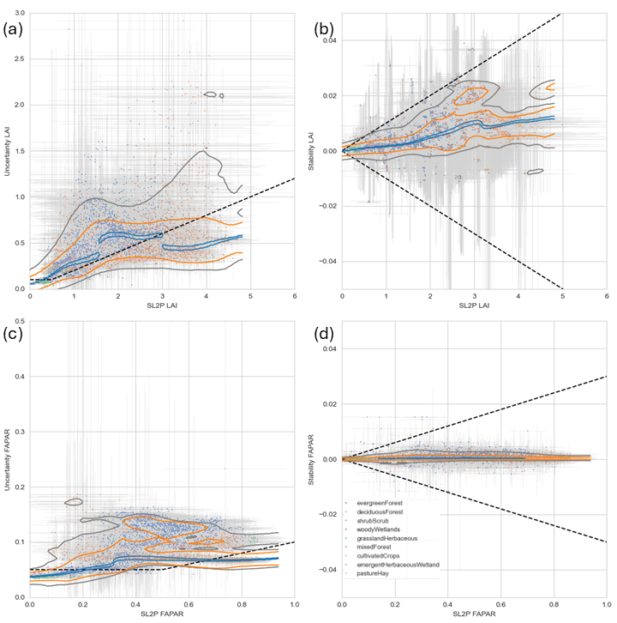
Figure 6. SL2P HLS estimation uncertainty for (a) LAI and (c) FAPAR over matchups and SL2P estimation stability for (b) LAI and (d) FAPAR over matchups. Contours indicate 0.67 (orange) and 0.90 (grey) cumulative conditional probability of bias given FRM. Blue line indicates weighted median bias conditional on FRM. Whiskers indicate one standard deviation intervals of estimates or FRM.

4.5 Conformity

Conformity considered the bivariate probability of the SL2P estimate and associated uncertainty or stability statistic for each FRM to determine the probability a matchup satisfied GCOS requirements. The probability matchups conformed with user requirements for uncertainty was generally very low for both LAI (<0.2,Figure 7a) and FAPAR (<0.1, Figure 7c ). The relatively large intervals for both SL2P estimates and validation statistics (whiskers in Figure 6 ) reduce the actual probability of conformity even for matchups whose expected values satisfy GCOC requirements. Additionally, intervals for estimates of uncertainty have an asymmetric effect since they are truncated at zero so the upper interval tends to reduce conformity probability more than the lower interval increases conformity probability . Only LAI conformity for non forested land cover matchups ever exceeded 0.5 probability suggesting that random errors over crops and grasslands may be lower than forests due to their lower structural diversity. FAPAR conformity for uncertainty was also low due to the extremely stringent GCOS requirements for relative standard uncertainty.

The probability matchups conformed with user requirements for stability was generally above 0.5 for both LAI ( Figure 7b) and FAPAR (Figure 7d ) and for the majority of matchups above 0.9. Conformity probabilities for LAI were generally lower at forest matchups versus non-forested matchups. Exceptionally, some shrubs and mixed forests had much lower conformity probabilities for FAPAR stability (<0.5) compared to other matchups. This was mainly due to the fact that these sites had a wide interval for their stability estimates due to having limited ( <=5 years) years with matchups.

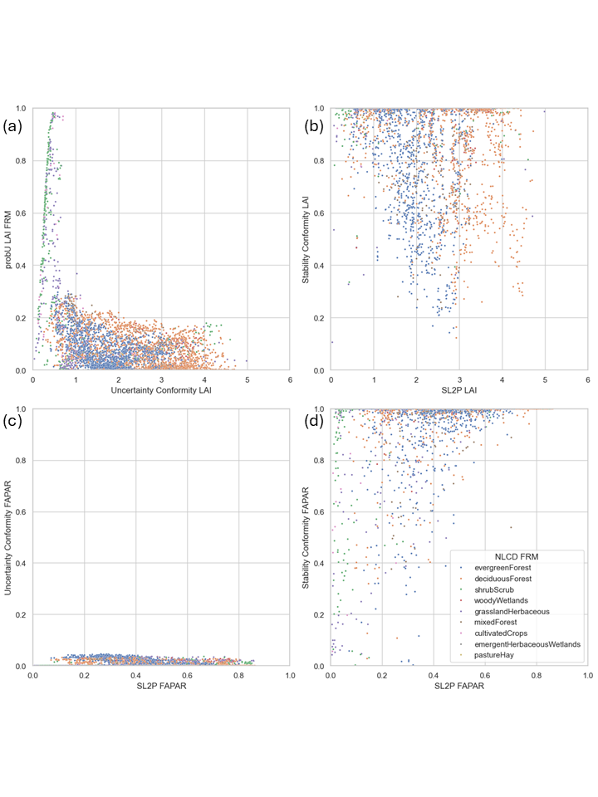
Figure 7. Probability of conforming with GCOS threshold requirements for (a) LAI uncertainty, (b) LAI stability, (c) FAPAR uncertainty, (d) FAPAR stability for individual matchups.

Given that conformity probabilities are sensitive both to the expected value and confidence intervals of validation statistics at individual FRMs the question as to whether the relatively large confidence intervals limit testing of GCOS requirements. Even assuming the stability and uncertainty expected values are zero (i.e. perfect SL2P estimates assuming comparisons with FRMs have no uncertainty) the conformity probability for LAI and FAPAR uncertainty for forest matchups only ranged from 0 to 0.8 (Figure 8a,c). In contrast, conformity probabilities for stability stay relatively unchanged suggesting the available matchups are sufficient to test stability requirements (Figure 8b,d).

Figure 8. Probability of conforming with GCOS threshold requirements for (a) LAI uncertainty, (b) LAI stability, (c) FAPAR uncertainty, (d) FAPAR stability for individual matchups.

4.6 Intercomparison

Intercomparisons of SL2P estimates are performed by comparing conditional intervals of uncertainty and stability (Figure 9) for SL2P HLS L30 products (sold contours) and SL2P HLS S30 products (dashed contours) rather than individual matchups due to the sensitivity of the latter to measurement errors and due to the fact that L30 and S30 FDRs may not be available for the same FRM. Contours corresponding to the conditional expected value of validation statistics (blue), the 67%ile interval (orange) and the extreme 90%ile interval (gray) were compared separately since products may agree for typical cases but disagree for matchups at specific sites or with specific acquisition conditions.

In terms of LAI uncertainty, for 90%ile and 67%ile intervals the S30 and L30 estimates had similar lower limits but the S30 uncertainty upper limits were between 20% to 40% lower than the L30 uncertainty. Additionally, for the 10%ile interval that includes the expected conditional uncertainty, while S30 and L30 uncertainty was similar for LAI<1.5 the S30 uncertainty gradual increased to ~0.35 past LAI 1.5 while the L30 uncertainty rapidly plateaus at ~0.5. These results highlight differences in both typical uncertainty and worst case uncertainty between L30 and S30 LAI estimates. In contrast FAPAR uncertainty contours were generally similar between S30 and L30 products. One exception being that cases of multimodal uncertainty estimates were more frequent for L30 versus S30 suggesting the former may be more susceptible to random effects associated with acquisition conditions such as atmospheric haze or shadows in contrast to slow varying land surface conditions such as canopy structure or optical properties.

S30 and L30 has virtually identical stability for the 10%ile intervals. However, for LAI, S30 had substantially worse stability than L30 products for the 90%ile intervals. This is likely due to the fact that S30 matchups spanned three fewer years than the L30 matchups and subsequently the prediction intervals for some S30 matchups was often large due to the limited number of sampled changes in bias over time. A longer time span of matchups is required to determine if this is the case or if the S30 product is less stable than L30 product for worst case conditions due to sensor differences in input reflectance data products or due to differences in spectral sampling between S30 and L30 algorithms.

Intercomparisons of conformity probability could also have been presented but were not conducted due to the previously documented sensitivity of conformity probability to the confideicne intervals of validation statistics. This sensitivity not only masks real differences between product estimates but also results in highly skewed conditional distributions of conformity probability (Figure 7) so that meaningful comparisons of even conditional distributions from different products are not currently possible.

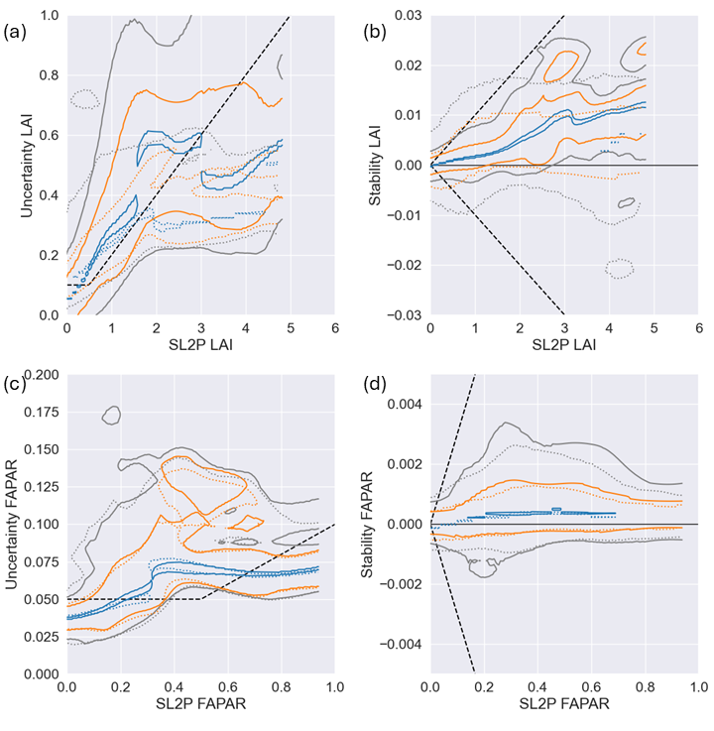
Figure 9. Contour plots of SL2P HLS L30 (solid lines) and SL2P HLS S2 (dotted lines) product estimates for (a) LAI uncertainty, (b) LAI stability, (a) LAI uncertainty, (b) LAI stability versus SL2P estimate. Uncertainty and stability are estimated all FRM measurements and parameters . Blacked dashed lines correspond to modified GCOS threshold requirements. . Contours indicate marginal probability of statistic given FRM for probability mass fractions for 0.1 (blue), 0.67 (orange) and 0.9 (grey).

4.7 Global Validation

CEOS Validation Stage 4 requires ongoing global product validation using FRM. The methodology for estimating global validation statistics is identical to that for estimates over a matchup with the exception of using only global parameters to model inclusion probabilities. The usefulness of this method relies on the extent to which statistics based on global parameters match (or at least are more pessimistic) than those based on all parameters available at a matchup and on the maximum relative inclusion probability for global product measurement conditions compared to the maximum relative inclusion probability observed for matchups.

LAI uncertainty estimates for matchups using inclusion probabilities estimated with global parameters while also holding out matchups at the same site (Uncertainty LAI global or simply global LAI uncertainty) shows a similar level of agreement for the uncertainty previously quantified using all FRM and parameters (Uncertainty LAI FRM or simply FRM LAI uncertainty) for low (<0.25) uncertainty (Figure 10a). For higher levels of uncertainty, the global LAI uncertainty was generally larger than the local FRM estimate by between 10% and 50%. Some exceptions were observed where the local FRM LAI uncertainty was substantially (over 100%) more than the global LAI uncertainty . However, these cases almost always corresponded to very large confidence intervals for the FRM uncertainty estimate so they correspond to biased FRM uncertainty estimates.

Global and FRM FAPAR uncertainty were similar for broadleaf vegetation but global estimates were between 26% and 100% greater than FRM estimates for needle leaf vegetation Figure 10b).. It is likely that this additional uncertainty for global vegetation is due to the lack of woody area index information when modelling global inclusion probabilities as the SL2P algorithm does not include woody area.

In contrast to uncertainty, global estimates of stability agree well with FRM estimates, with differences typically smaller than the confidence intervals of estimates for a given matchup Figure 10c,d)..
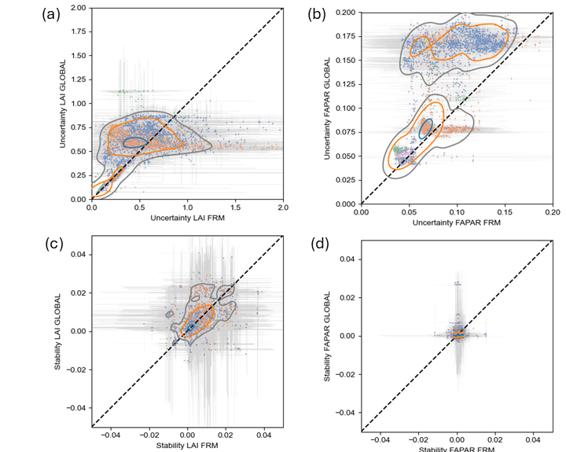
Figure 10. Comparison of Uncertainty and Stability as a function of product measurement using estimates based on all FRM measurements and parameters (FRM) versus FRM measurements at other sites and global parameters (GLOBAL). . Contours indicate joint central probability mass fractions for 0.1 (blue), 0.67 (orange) and 0.9 (grey). Whiskers indicate one standard deviation intervals of estimates.

Maximum annual SL2 HLS L30 retrievals, together with associated maximum inclusion probability, uncertainty and stability were estimated for the global 100km grid samples. Monthly or daily values are possible but not shown for brevity. Patterns of both LAI (Figure 11a) and FAPAR (Figure 12a) are plausible considering the SL2P algorithm bias, but their relevance to downstream use cases beyond the scope of this study.

Maximum inclusion probabilities for LAI (Figure 11b) are generally high in temperate and sub-arctic biomes and low in equatorial regions and south-central Asia. This is expected given the location of matchups (Figure 2). FAPAR maximum inclusion probability (Figure 12b) showed a similar spatial pattern but approximately 50% lower. This follows because prior estimates of SL2P FAPAR relative standard uncertainty are generally below 5% while those for LAI typically exceed 10% (see Figure 4) so differences between SL2P FAPAR estimates over matchups versus estimates at global locations result in a large drop in inclusion probability compared to differences for SL2P LAI estimates. The FAPAR inclusion probability could be revised using posterior uncertainty estimates (Figure 6) but the spatial pattern still identifies where matchup conditions are under sampled.

LAI uncertainty (Figure 11c) are and FAPAR uncertainty (Figure 12c) are generally proportional to the SL2P estimate with the exception of central Africa where they are indicated as relatively large but one should keep in mind this region is likely not represented by matchups. In contrast, stability is generally very good (near 0yr-1) for both LAI (Figure 11d) are and FAPAR (Figure 12d) but there are isolated areas of poor stability in Europe, the central US and the Boreal zone. These areas may correspond to regions with land cover change, resulting in changes in bias over time related to the land surface rather than observing system. This result identifies a weakness with our approach to quantifying stability since it does not distinguish between these sources of bias change over time.
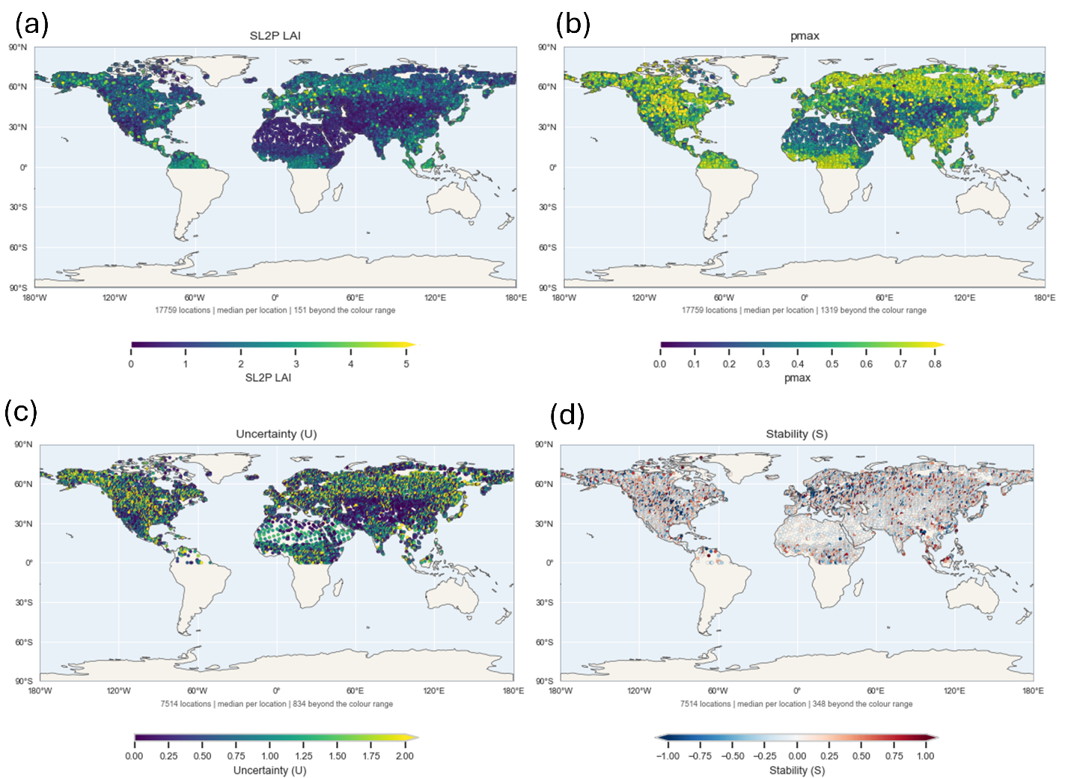
Figure 11. Global 100km grid samples of (a) maximum SL2P HLS L30 LAI and associated (b) inclusion probability, (c ) uncertainty and (d) stability.
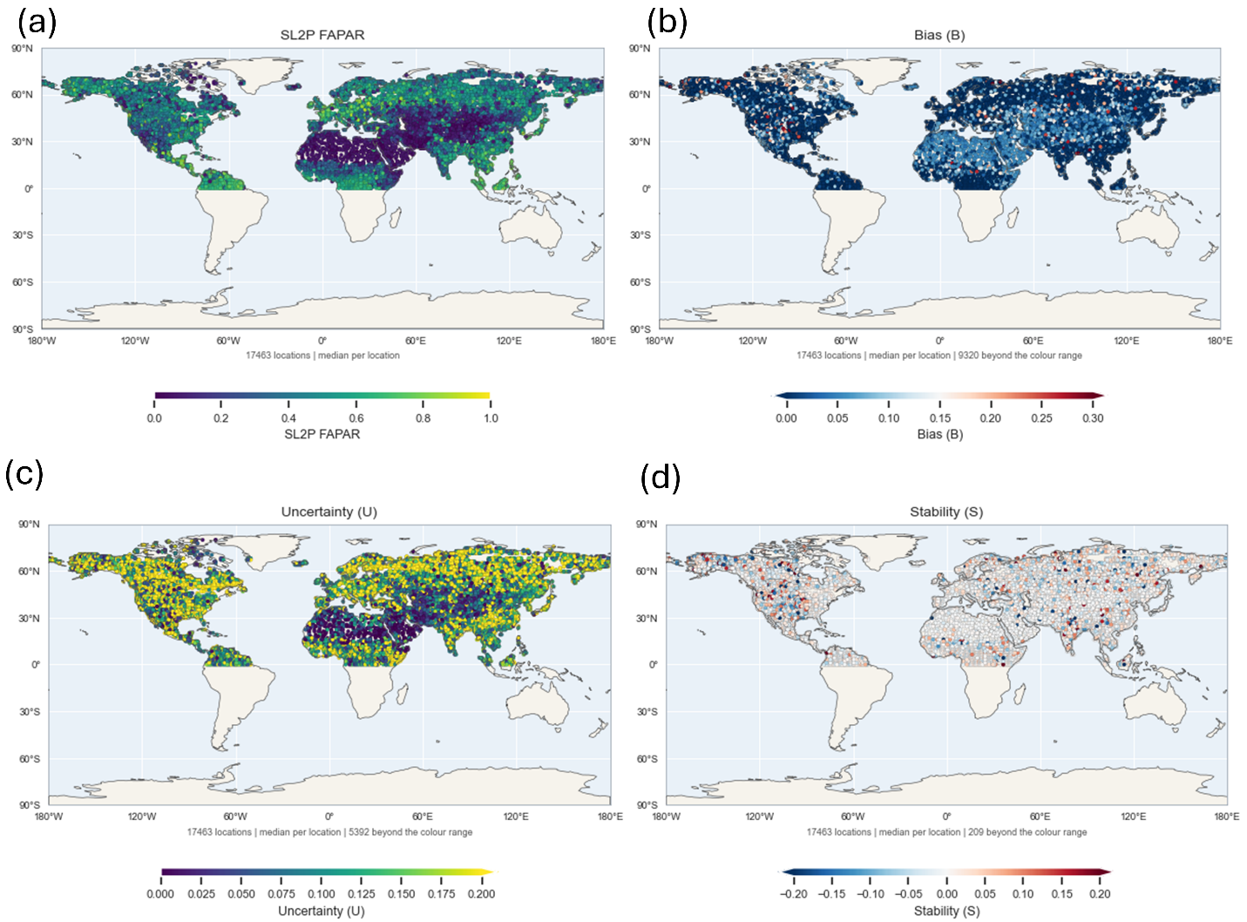
Figure 12. Global 100km grid samples of (a) maximum SL2P HLS L30 FAPAR and associated (b) inclusion probability, (c ) uncertainty and (d) stability.

Supplementary Material S1 – Estimation of Woody Area Index

Supplementary Material S2 – Comparison of Site Specific Quality Statistics as a function of heterogeneity.

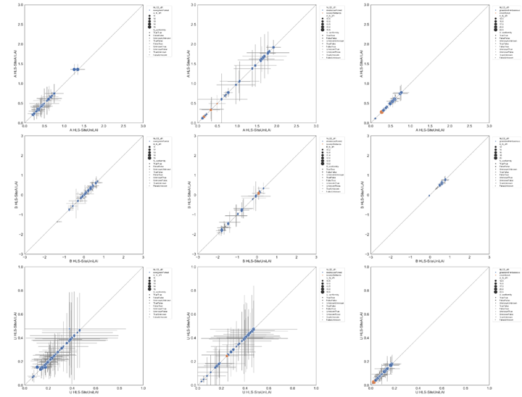
Figure S1.1 Comparison of LAI quality statistics for site specific experiments using all FRM (x-axis) and only homogenous FRM (y-axis). Whiskers correspond to one standard deviation confidence intervals. Colors indicate land cover class. Shape indicates conformity to GCOS requirements for the all FRM experiment. Stability not presented due to lack of matchups with effective degrees of freedom >=10.

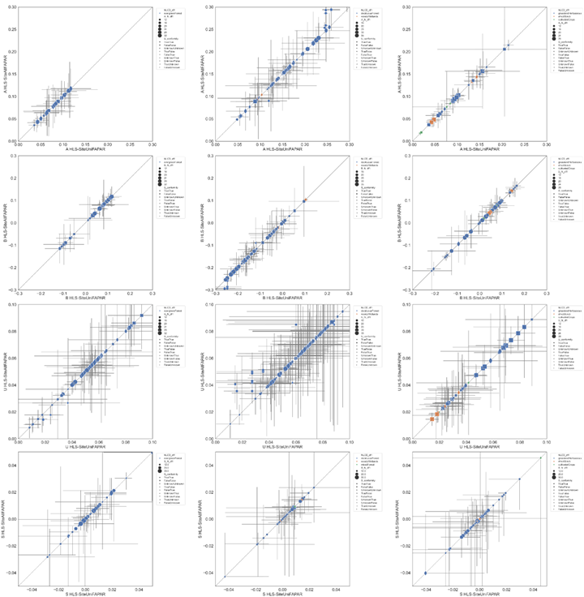
Figure S1.2 Comparison of FAPAR quality statistics for site specific experiments using all FRM (x-axis) and only homogenous FRM (y-axis). Whiskers correspond to one standard deviation confidence intervals. Colors indicate land cover class. Shape indicates conformity to GCOS requirements for the all FRM experiment.

Supplementary Material S2 – Comparison of conditional quality statistics between site specific and all sites matchup experiments for wide interval sampling

Figure S1.2 Conditional LAI quality statistics based on only site specific matchups (red) and all matchups (blue). (Note: I will add scatter plots of all matchups for context).

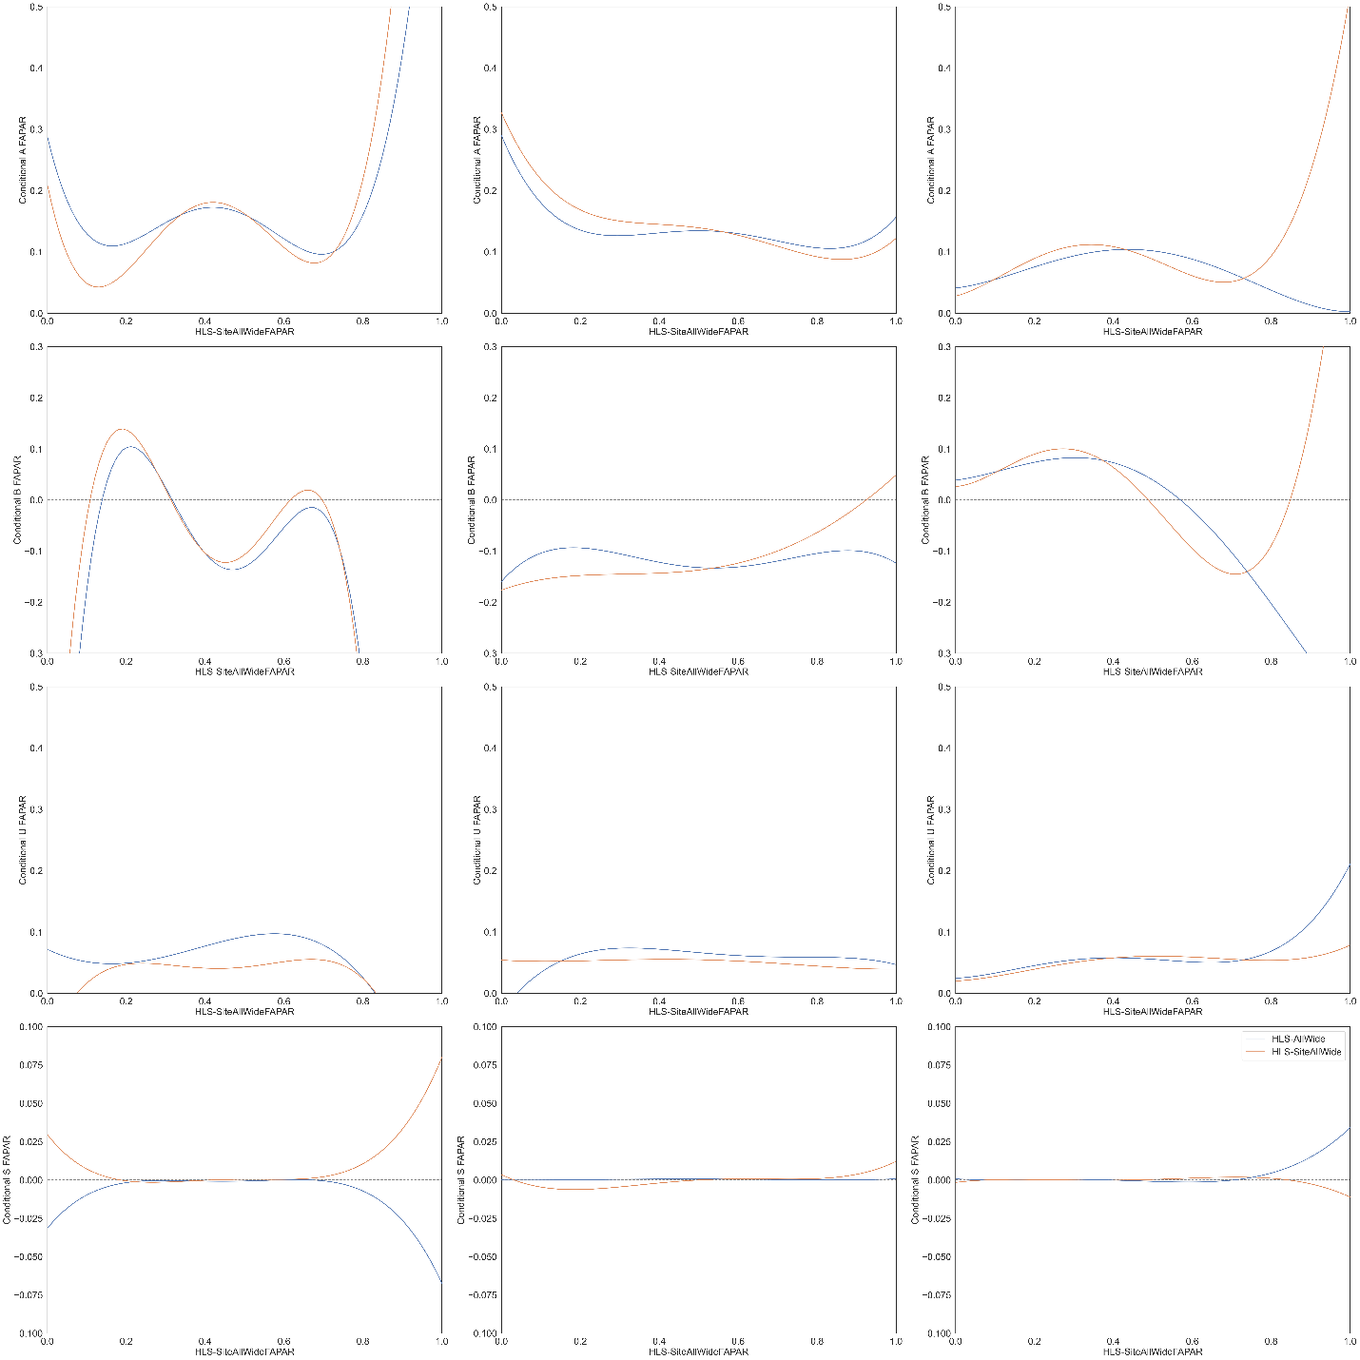
Figure S2.2 Conditional FAPAR quality statistics based on only site specific matchups (red) and all matchups (blue). (Note: I will add scatter plots of all matchups for context).

Supplementary Material S3 – Comparison of quality statistics between site specific and all site matchup conditions.

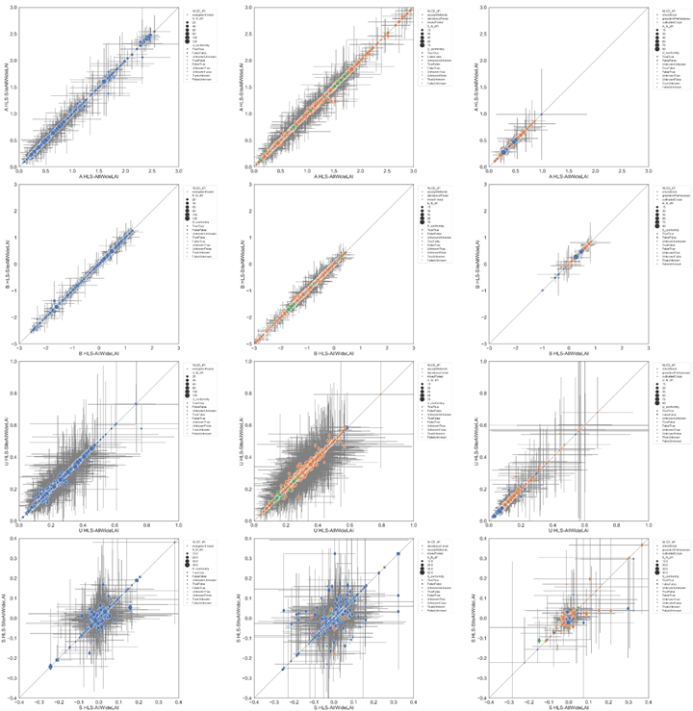
Figure S3.1 Comparison of LAI quality statistics between site specific experiments using all FRM with wide matchup intervals(x-axis) and all FRM with wide matchup intervals (y-axis). Whiskers correspond to one standard deviation confidence intervals. Colors indicate land cover class. Shape indicates conformity to GCOS requirements for the all FRM experiment for both experiments.

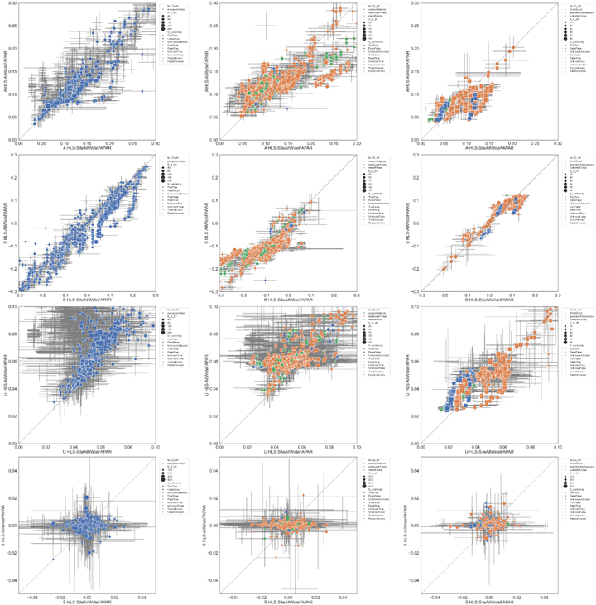
Figure 3.2 Comparison of FAPAR quality statistics between site specific experiments using all FRM with wide matchup intervals(x-axis) and all FRM with wide matchup intervals (y-axis). Whiskers correspond to one standard deviation confidence intervals. Colors indicate land cover class. Shape indicates conformity to GCOS requirements for the all FRM experiment for both experiments.

Discussion

This study represents a departure from virtually all previous LAI/FAPAR validation studies with the partial exception of Camacho et al., 2024 in that it actually performs validation of user requirements rather than simply presenting statistical summary of residuals between product measurements and matching reference measurements. Even the prior CEOS good practice (Fernandes et al., 2014) did not actually assess conformity. This gap between practice and need brings into question the relevance of the majority of validation studies to the mission requirements of satellite observing systems targeted in mapping LAI/FAPAR or to requirements from bodies such as GCOS or the Copernicus Global Land Monitoring Service. There are three major gaps in terms of the goal of the validation experiment addressed here for the first time:

- Most LAI/FAPAR user requirements specify a target for relative standard uncertainty. This is reasonable both because modelling studies suggest measurement errors for LAI, and to some extent FAPAR, are multiplicative (Weiss et al., 2020) and because these translate into relative errors in fluxes and indicators derived from models that consume LAI/FAPAR inputs (GCOS, 2024). But previous studies, including Camacho et al., 2024) do not actually quantified uncertainty using reference measurements since they do not apply bias correction and since the majority of studies report error statistics either for entire ranges of LAI/FAPAR found in the reference database as recommended by Berger et al. (2019) or conditional on the reference measurement as recommended by Fernades et al. (2014).
- Previous studies have not provided an approach to identify the replicates required for quantifying uncertainty or bias using FRM. This is a challenging task for LAI/FAPAR products since there are numerous sources of error that vary in space and time in a manner that cannot be easily controlled. Moreover, sources of error such as the actual LAI/FAPAR, the clumping index, woody area index are not generally available except at in-situ FRM sampling sites. Folling guidance from the Joint Council on Metrology, this problem is addressed here by modelling inclusion probabilities both at FRM and globally using parameters. The models used here are admittedly incomplete as not all error sources are described even for FRM. This will generally result in pessimistic estimates of uncertainty, as seen when comparing FRM versus GLOBAL uncertainty estimates, since replicates will include variability due to different error conditions. Improved uncertainty estimates would require additional FRM sampling over different conditions that is not available with current datasets.
- This is only the second study that quantified LAI/FAPAR stability. Djamai et al. (2024) produced an initial estimate of stability for individual ESUs with sufficient temporal sampling by comparing changes in bias between successive years. We extent this approach by first using robust regression approaches to quantify ESU stability and then using the same inclusion probabilities defined for uncertainty to estimate stability based on all similar ESUs.

Our study also followed QA4EO good practice of propagating uncertainty from both product and reference measurements to validation statistics and conformity probabilities. In contrast to most other studies, robust rank order statistics were used to reduce the impact of FRM measurement errors, matchup uncertainty due to temporal and spatial mismatch, and assumptions regarding inclusion probabilities on validation statistics. This approach required detailed but relatively mature statistic theory that may be unfamiliar to the earth observation community but that is essential to our method. To this end we have provided open source code to replicate our study so the community can adapt it for future use.

The actual uncertainty and stability of SL2P products are not critical to discuss as our study focused on methodology. Suffice it to note that LAI and FAPAR relative standard uncertainty are large and even their expected values exceed the GCOS requirements for the majority of comparisons at FRM sites while stability is generally within GCOS requirements. However, there are two important aspects for our method that are not usually addressed in other validation studies:

- The conditional distribution of uncertainty for a given product measurement varies with the product measurement magnitude in a non-linear and multimodal manner. This result clearly indicates that population statistics for uncertainty can be misleading for testing user requirements. Fernandes et al. (2024) anticipated the need to model uncertainty as a function of product measurement using robust regression fits but even this approach can be misleading if the uncertainty is multimodal. Our method relies on explicitly estimating and visualizing conditional distributions of uncertainty. While not offering the simplicity of population or regression estimators this approach not only accounts for complex uncertainty patterns but allows for comparisons between products based on different sets of matchups.
- It is critical to have realistic (or at least pessimistic) estimates of confidence intervals for both the desired validation statistics (uncertainty or stability in our case) and product measurement to test conformity. Previous studies (Widlowski et al., 2016; Camacho et al. 2024) demonstrated the need to include confidence intervals to determine if an uncertainty estimate conforms with a requirement at better than a certain probability level. Here, we generalize this approach by simply reporting the probability of conformity for each estimate of uncertainty or stability. This allows users of product to decide on a per-retrieval basis if the conformity probability is sufficient for their application.

Probability of conformity for uncertainty were generally very low for LAI and for many of the lower FAPAR estimates. This is partly due to the sources of error in the product measurement but it is unfortunately also due to the large confidence intervals of uncertainty estimates. Indeed, even assuming zero uncertainty results is conformity probabilities < 0.25 for the majority of matchups. This issue is unlikely to be improved by more certain FRM since product uncertainty will still result in wide confidence intervals. Increasing matchups within replicates will reduce confidence intervals but even this will decrease quadratically in efficiency. It may be that current matchups do not allow for testing conformity of SL2P LAI and FAPAR estimates to stringent GCOS requirements without further control of error conditions. This could be performed for well monitored super sites but would offer limited benefit for global conditions. An alternative may be to develop simulation models for synthetic sites but this would require CEOS and GCOS to permit validation without using FRM. Until that time it may be more useful to simply consider the expected value of uncertainty when evaluating product fitness.

Global estimation of uncertainty are stability are simplified by the fact that, for most cases, the use of global inclusion probabilities results in pessimistic estimates of both statistics. This is expected since the simplified inclusion probabilities, based only on land cover, climate and the product estimate, will include a greater range of error conditions within replicates. That said, the maximum inclusion probability provides a useful relative indicator as to whether the estimate uncertainty or stability for a arbitrary retrieval are based on similar FRM sites. Further analysis of the agreement between global and site specific uncertainty and stability as a function of the maximum inclusion probability should be performed but is beyond the scope of this study. We also only presented results for peak global LAI/FAPAR for brevity. Analysis of temporal trends in uncertainty may be informative as to both mission performance and the expected range over time. Stability estimates seem to have low maximum inclusion probabilities in areas with vegetation disturbance (agricultural areas with changing land cover and burnt areas) as these areas are not well represented in the GroundEO FRM. Quantifying stability due to algorithm or sensor inputs versus land cover change is not addressed here but may be facilitated by using land cover change information to partition stability estimates.

While this study provides practical approaches for quantifying the uncertainty and stability of moderate resolution LAI/FAPAR products it had two major limitations. Firstly, it used only a single FRM dataset and similar input satellite data records and mapping algorithms. While there is no reason to suspect that the validation method could apply to other reference and product data one should note that validation using other datasets may result in less consistency in results if matchups are limited (e.g. using products from recently launched sensors or from sensors with limited spatial sampling such as GEDI) or if FRM have systematic errors themselves. It remains for the community to apply these methods to additional datasets and refine them as issues arise. Secondly, this study represents a major break from convention in both the use of replicates based on inclusion probabilities and in the use of robust conditional statistics. This is a real limit since it seems that the authors and editors of most validation studies are happy to simply report population accuracy statistics and bias estimates assuming linear bias as a function of reference measurements. This is both of limited relevance to current product user requirements and could result in incorrect conclusions when comparing products. The study focused on mathematical detailed and could benefit from future studies comparing validation using our approach with the status quo. Finally, the lack of dense spatial and temporal coverage of FRM is a limiting factor for conformity testing. New automated temporal sampling systems would increase the diversity of validated error conditions but would likely not include cases such as disturbance and land use change where remote LAI/FAPAR monitoring is often the only available dataset. Again, a validation platform based on simulated measurements, themselves traceable to FRM, may be a necessary compromise.

Conclusion

(C

Uuu)) =

SS

B

yE-yEe-Bbe

MPEEEAAae

u

pee

p=1a

p=1

- =-
- =-
- =-f fyxfxx

==

a

u ay

P(e)

- eP(e)

P(e)eyyy>00≥y≤1P(e)P(e)P

=

=

P()P()P(e)P()

TB

uSau()a()=a()b()S

P(e)

N
=

=

Nn

=n

,
=
,

=

PCP>0.0015
=

,
=
,

=

.

Acknowledgements

References
Berger, K., Atzberger, C., Hank, T., & Mauser, W. (2012). Derivation of biophysical variables from Earth observation data: Validation and statistical measures. Journal of Applied Remote Sensing, 6, 063557-1. https://doi.org/10.1117/1.JRS.6.063557
Brown, L. A., Camacho, F., García-Santos, V., Origo, N., Fuster, B., Morris, H., Pastor-Guzman, J., Sánchez-Zapero, J., Morrone, R., Ryder, J., et al. (2021a). Fiducial reference measurements for vegetation bio-geophysical variables: An end-to-end uncertainty evaluation framework. Remote Sensing, 13(16), 3194. https://doi.org/10.3390/rs13163194
Brown, L., Fernandes, R., Djamai, N., Meier, C., Gobron, N., Morris, H., Canisius, F., Bai, G., Lerebourg, C., Lanconelli, C., Clerici, M., & Dash, J. (2021b). Validation of baseline and modified Sentinel-2 Level 2 Prototype Processor leaf area index retrievals over the United States. ISPRS Journal of Photogrammetry and Remote Sensing, 175, 71–87. https://doi.org/10.1016/j.isprsjprs.2021.02.020
Brown, L. A., Fernandes, R., Verrelst, J., Morris, H., Djamai, N., Reyez-Muñoz, P., Kovács, D., & Meier, C. (2025). GROUNDED EO: Data-driven Sentinel-2 LAI and FAPAR retrieval using Gaussian processes trained with extensive fiducial reference measurements. Remote Sensing of Environment. https://doi.org/10.1016/j.rse.2025.114797
Brown, L. A., Meier, C., Morris, H., Pastor-Guzman, J., Bai, G., Lerebourg, C., Gobron, N., Lanconelli, C., Clerici, M., & Dash, J. (2020). Evaluation of global leaf area index and fraction of absorbed photosynthetically active radiation products over North America using Copernicus Ground Based Observations for Validation data. Remote Sensing of Environment, 247, 111935.
Buchhorn, M., Lesiv, M., Tsendbazar, N.-E., Herold, M., Bertels, L., & Smets, B. (2020). Copernicus Global Land Cover Layers—Collection 2. Remote Sensing, 12(6), 1044. https://doi.org/10.3390/rs12061044
Camacho, F., Martínez-Sánchez, E., Brown, L. A., Morris, H., Morrone, R., Williams, O., Dash, J., Origo, N., Sánchez-Zapero, J., & Boccia, V. (2024). Validation and conformity testing of Sentinel-3 Green Instantaneous FAPAR and canopy chlorophyll content products. Remote Sensing, 16(15), 2698. https://doi.org/10.3390/rs16152698
Campos-Taberner, M., García-Haro, F. J., Camps-Valls, G., Grau-Muedra, G., Nutini, F., Busetto, L., Katsantonis, D., Stavrakoudis, D., Minakou, C., Gatti, L., Barbieri, M., Holecz, F., Stroppiana, D., & Boschetti, M. (2017). Exploitation of SAR and optical Sentinel data to detect rice crop and estimate seasonal dynamics of leaf area index. Remote Sensing, 9(3), 248. https://doi.org/10.3390/rs9030248
CEOS. (2018). Space agency response to GCOS implementation plan (Version 2.2.1). Joint CEOS/CGMS Working Group on Climate (WGClimate).
Chabrillat, S., Guanter, L., Kaufmann, H., Foerster, S., Beamish, A., Brosinsky, A., Wulf, H., Asadzadeh, S., Bochow, M., Bohn, N., Boesche, N., Bracher, A., Brell, M., Buddenbaum, H., Cerra, D., Fischer, S., Hank, T., Heiden, U., Heim, B., Heldens, W., Hill, J., Hollstein, A., Hostert, P., Krasemann, H., LaPorta, L., Leitão, P. J., van der Linden, S., Mauser, W., Milewski, R., Mottus, M., Okujeni, A., Oppelt, N., Pinnel, N., Roessner, S., Röttgers, R., Schneiderhan, T., Schickling, A., Soppa, M., Staenz, K., & Segl, K. (2022). EnMAP science plan (EnMAP Technical Report). GFZ Data Services. https://doi.org/10.48440/enmap.2022.001
Commission for Environmental Cooperation. (2023). 2020 land cover of North America at 30 meters. North American Land Change Monitoring System. https://developers.google.com/earth-engine/datasets/catalog/USGS_NLCD_RELEASES_2020_REL_NALCMS
Defourny, P., Bontemps, S., Bellemans, N., Cara, C., Dedieu, G., Guzzonato, E., Hagolle, O., Inglada, J., Nicola, L., Rabaute, T., Savinaud, M., Udroiu, C., Valero, S., Bégué, A., Dejoux, J.-F., El Harti, A., Ezzahar, J., Kussul, N., Labbassi, K., . . . Koetz, B. (2019). Near real-time agriculture monitoring at national scale at parcel resolution: Performance assessment of the Sen2-Agri automated system in various cropping systems around the world. Remote Sensing of Environment, 221, 551–568. https://doi.org/10.1016/j.rse.2018.11.007
Djamai, N., Fernandes, R. A., Sun, L., Canisius, F., & Hong, G. (2024). Python version of Simplified Level 2 Prototype Processor for retrieving canopy biophysical variables from Sentinel-2 multispectral data (Geomatics Canada Open File 81). https://doi.org/10.4095/p8stuehwyc
Dubayah, R., Blair, J. B., Goetz, S., Fatoyinbo, L., Hansen, M., Healey, S., Hofton, M., Hurtt, G., Kellner, J., Luthcke, S., Armston, J., Tang, H., Duncanson, L., Hancock, S., Jantz, P., Marselis, S., Patterson, P. L., Qi, W., & Silva, C. (2020). The Global Ecosystem Dynamics Investigation: High-resolution laser ranging of the Earth’s forests and topography. Science of Remote Sensing, 1, 100002. https://doi.org/10.1016/j.srs.2020.100002
Fang, H., Baret, F., Plummer, S., & Schaepman-Strub, G. (2019). An overview of global leaf area index (LAI): Methods, products, validation, and applications. Reviews of Geophysics, 57, 739–799. https://doi.org/10.1029/2018RG000608
Food and Agriculture Organization of the United Nations. (2025). Global forest resources assessment 2025. https://doi.org/10.4060/cd6709en
Fernandes, R., Brown, L., Canisius, F., Dash, J., He, L., Hong, G., Huang, L., Le, N. Q., MacDougall, C., Meier, C., Darko, P. O., Shah, H., Spafford, L., & Sun, L. (2023). Validation of simplified Level 2 Prototype Processor Sentinel-2 fraction of canopy cover, fraction of absorbed photosynthetically active radiation, and leaf area index products over North American forests. Remote Sensing of Environment, 293, 113600. https://doi.org/10.1016/j.rse.2023.113600
Fernandes, R., Djamai, N., Harvey, K., Hong, G., MacDougall, C., Shah, H., & Sun, L. (2024). Evidence of a bias-variance trade-off when correcting for bias in Sentinel-2 forest LAI retrievals using radiative transfer models. Remote Sensing of Environment, 305, 114060. https://doi.org/10.1016/j.rse.2024.114060
Fernandes, R., Plummer, S., Nightingale, J., Baret, F., Camacho, F., Fang, H., Garrigues, S., Gobron, N., Lang, M., Lacaze, R., Leblanc, S., Meroni, M., Martinez, B., Nilson, T., Pinty, B., Pisek, J., Sonnentag, O., Verger, A., Welles, J., Weiss, M., Widlowski, J.-L., Schaepman-Strub, G., Roman, M., & Nickeson, J. (2014). Global leaf area index product validation good practices. In R. Fernandes, S. Plummer, & J. Nightingale (Eds.), Best practice for satellite-derived land product validation. Land Product Validation Subgroup, Committee on Earth Observation Satellites Working Group on Calibration and Validation. https://doi.org/10.5067/DOC/CEOSWGCV/LPV/LAI.002
Fernandes, R., Tang, H., & Brown, L. (2024a). Proposed definition of leaf area index by the Committee on Earth Observation Satellites (Geomatics Canada Open File 86). https://doi.org/10.4095/p9fzmg1djq
Fernandes, R., Tang, H., & Brown, L. (2024b). Proposed definition of fraction of absorbed photosynthetically active radiation by the Committee on Earth Observation Satellites (Geomatics Canada Open File 85, Version 1.0). https://doi.org/10.4095/p3gy844zex
Fuster, B., Sánchez-Zapero, J., Camacho, F., García-Santos, V., Verger, A., Lacaze, R., Weiss, M., Baret, F., & Smets, B. (2020). Quality assessment of PROBA-V LAI, fAPAR and fCOVER Collection 300 m products of Copernicus Global Land Service. Remote Sensing, 12(6), 1017. https://doi.org/10.3390/rs12061017
Gascon, F., Bouzinac, C., Thépaut, O., Jung, M., Francesconi, B., Louis, J., Lonjou, V., Lafrance, B., Massera, S., Gaudel-Vacaresse, A., Languille, F., Alhammoud, B., Viallefont, F., Pflug, B., Bieniarz, J., Clerc, S., Pessiot, L., Trémas, T., Cadau, E., . . . Fernandez, V. (2017). Copernicus Sentinel-2A calibration and products validation status. Remote Sensing, 9(6), 584. https://doi.org/10.3390/rs9060584
Gaudel, A., Languille, F., Delvit, J., Michel, J., Cournet, M., & Poulain, V. (2017). Sentinel-2 global reference image validation and application to multitemporal performances and high latitude digital surface model. The International Archives of the Photogrammetry, Remote Sensing and Spatial Information Sciences, XLII-1/W1, 447–454. https://doi.org/10.5194/isprs-archives-XLII-1-W1-447-2017
GEOGLAM. (2022). Full EAV table | AgVariables. https://agvariables.org/
Joint Committee for Guides in Metrology. (2012). The role of measurement uncertainty in conformity assessment (JCGM 106:2012). https://doi.org/10.59161/JCGM106-2012
Joint Committee for Guides in Metrology. (2021). International vocabulary of metrology—Basic and general concepts and associated terms (4th ed.; JCGM-WG2-CD-01).
Ju, J., Zhou, Q., Freitag, B., Roy, D. P., Zhang, H. K., Sridhar, M., Mandel, J., Arab, S., Schmidt, G., Crawford, C. J., Gascon, F., Strobl, P. A., Masek, J. G., & Neigh, C. S. R. (2025). The Harmonized Landsat and Sentinel-2 Version 2.0 surface reflectance dataset. Remote Sensing of Environment, 324, 114723. https://doi.org/10.1016/j.rse.2025.114723
Lanconelli, C., Cappucci, F., Adams, J., & Gobron, N. (2024). Evaluation of in situ FAPAR measurement protocols using 3D radiative transfer simulations. Remote Sensing, 16(23), 4552. https://doi.org/10.3390/rs16234552
Malenovský, Z., Rott, H., Cihlar, J., Schaepman, M. E., García-Santos, G., Fernandes, R., & Berger, M. (2012). Sentinels for science: Potential of Sentinel-1, -2, and -3 missions for scientific observations of ocean, cryosphere, and land. Remote Sensing of Environment, 120, 91–101. https://doi.org/10.1016/j.rse.2011.09.026
Monteith, J. L. (1972). Solar radiation and productivity in tropical ecosystems. Journal of Applied Ecology, 9(3), 747–766. https://doi.org/10.2307/2401901
Muñoz-Sabater, J., Dutra, E., Agustí-Panareda, A., Albergel, C., Arduini, G., Balsamo, G., Boussetta, S., Choulga, M., Harrigan, S., Hersbach, H., Martens, B., Miralles, D. G., Piles, M., Rodríguez-Fernández, N. J., Zsoter, E., Buontempo, C., & Thépaut, J.-N. (2021). ERA5-Land: A state-of-the-art global reanalysis dataset for land applications. Earth System Science Data, 13, 4349–4383. https://doi.org/10.5194/essd-13-4349-2021
Navarro, L. M., Fernández, N., Guerra, C., Guralnick, R., Kissling, W. D., Londoño, M. C., et al. (2017). Monitoring biodiversity change through effective global coordination. Current Opinion in Environmental Sustainability, 29, 158–169.
Nobel, A. (1996). Histogram regression estimation using data-dependent partitions. The Annals of Statistics, 24(3), 1084–1105. https://doi.org/10.1214/aos/1032526958
Stavros, E. N., Chrone, J., Cawse-Nicholson, K., Freeman, A., Glenn, N. F., Guild, L., Kokaly, R., Lee, C., Luvall, J., Pavlick, R., Poulter, B., Schollaert Uz, S., Serbin, S., Thompson, D. R., Townsend, P. A., Turpie, K., Yuen, K., Thome, K., Wang, W., Zareh, S. K., Nastal, J., Bearden, D., Miller, C. E., & Schimel, D. (2023). Designing an observing system to study the surface biology and geology (SBG) of the Earth in the 2020s. Journal of Geophysical Research: Biogeosciences, 128(1), e2021JG006471. https://doi.org/10.1029/2021JG006471
Stehman, S. V., & Czaplewski, R. L. (1998). Design and analysis for thematic map accuracy assessment: Fundamental principles. Remote Sensing of Environment, 64, 331–344. https://doi.org/10.1016/S0034-4257(98)00010-8
Tyukavina, A., Stehman, S. V., Foody, G. M., Bontemps, S., See, L., Olofsson, P., Tsendbazar, N., Radoux, J., Komarova, A., Serre, B., Song, X., d’Andrimont, R., Koren, G., Potapov, P., Bullock, E. L., Campbell, P., de Bruin, S., Defourny, P., Friedl, M. A., Fritz, S., et al. (2025). Land cover and change map accuracy assessment and area estimation good practices protocol (Version 1.0). CEOS Working Group on Calibration and Validation. https://doi.org/10.5067/DOC/CEOSWGCV/LPV/LC.001
United Nations, Department of Economic and Social Affairs, Statistics Division. (2022). Guidelines on biophysical modelling for ecosystem accounting. https://seea.un.org/ecosystem-accounting/biophysical-modelling
Verger, A., Weiss, M., & Baret, F. (2025). GEOV2-AVHRR: Continuous and consistent time series of global leaf area index and fraction absorbed PAR from 1981 to 2022. Remote Sensing of Environment, 331, 115029. https://doi.org/10.1016/j.rse.2025.115029
Watson, D. J. (1947). Comparative physiological studies in the growth of field crops. I. Variation in net assimilation rate and leaf area between species and varieties, and within and between years. Annals of Botany, 11. https://doi.org/10.1093/oxfordjournals.aob.a083148
Weiss, M., Baret, F., & Jay, S. (2020). S2ToolBox Level 2 products: LAI, FAPAR, FCOVER (Version 2.0). https://step.esa.int/docs/extra/ATBD_S2ToolBox_L2B_V2.0.pdf
Widlowski, J.-L. (2015). Conformity testing of satellite-derived quantitative surface variables.
World Meteorological Organization. (2022). GCOS implementation plan 2022: The global observing system for climate (GCOS-245, GOOS-269, WMO-No. 1299). https://gcos.wmo.int/en/gcos-implementation-plan-2022
World Meteorological Organization. (2025). The 2022 GCOS ECVs requirements: 2022 edition—Updated in 2025 (GCOS-245). https://library.wmo.int/idurl/4/58111
Zanaga, D., Van De Kerchove, R., De Keersmaecker, W., Souverijns, N., Brockmann, C., Quast, R., Wevers, J., Grosu, A., Paccini, A., Vergnaud, S., Cartus, O., Santoro, M., Fritz, S., Georgieva, I., Lesiv, M., Carter, S., Herold, M., Li, L., Tsendbazar, N.-E., Ramoino, F., & Arino, O. (2021). ESA WorldCover 10 m 2020 v100. https://doi.org/10.5281/zenodo.5571936

Supplementary Material S1. Definitions of Quantities – This will be updated using glossary only

Definitions of metrological quantities used to validate uncertainty and stability (Table 4) and thematic and geographical aspects of products and FRM (Table 5 and Table 6) are fundamental to ensure there is community agreement on good practice.
based on definitions from the Global Climate Observing System (GCOS, https://obssea4clim.eu/about-2/glossary/) the_ Joint Committee for Guides in Metrology (JGCM, 2021), the Quality Assurance Framework for Earth Obswervation (QA4EO, NPL QA4EO team , 2022) or the Committee of Earth Observation Satellites (CEOS, https://ceos-org.github.io/eo-glossary/ ).

Metrological Definitions

Metrological definitions for quantities required to quantify uncertainty and stability are taken from the Guide to the Expression of Uncertainty in Measurement (JCGM, 2008) where applicable (Table 6). Additional definitions, relevant to validating LAI/FAPAR products are also included. All validated quantities are defined with respect to a condition that, for CEOS Stage 4, corresponds to set of locations and time periods representing global conditions spanning multiple years.
Table 16. Metrological terms (terms and defintitions in bold are taken from GUM xx).
Term | Symbol | Definition
Measureand | $$Y$$ | quantity intended to be measured
Measurement | $$\hat{y}$$ | value attributed to a measurand, obtained by measurement under specified conditions
Condition of measurement | $$c$$ | Conditions of measurement including  — - - principle of measurement  — method of measurement  — observer  — measuring instrument  — reference standard  — location  — conditions of use  — time.
Conventional true value | $$\hat{Y}$$ | Value attributed to a particular quality (e.g. measureand) having uncertainty appropriate for use (validation)
Fiducial reference measurement | $$\tilde{y}$$ | independent, fully characterised, and traceable (to a community agreed reference) measurements of a satellite relevant measurand, tailored specifically to address the calibration/validation needs of a class of satellite borne sensor and that follow community guidelines. (NPL QA4EO, 2025)
Standard Uncertainty | $$U$$ | uncertainty of the result of a measurement under a specified condition expressed as the standard deviation of the dispersion of the values that could reasonably be attributed to the measurand
Relative Standard Uncertainty | $$U_{r}$$ | Standard uncertainty divided by the value of the measurement
Systematic Error | $$A$$ | Expected value of measurement of same conditions minus the conventional true value, synonymous with accuracy
Stability | $$S$$ | Rate of change in A per year expressed as a percentage of the concentional true value (WMO, 2024
Random Error | $$p$$ | result of a measurement minus the expected value of measurements under same conditions,
Type A standard uncertainty | $$U_{A}$$ | standard uncertainty is obtained from a probability density function derived from an observed frequency distribution
Type B standard uncertainty | $$U_{B}$$ | Estimate of standard uncertainty obtained from an assumed  probability density function based on the degree of belief that an event will occur  probability (C.2.1)].

Thematic Definitions

LAI and FAPAR
LAI and FAPAR have definitions accepted by both WMO and CEOS (Table 6). For brevity, definitions for related quantities often reported both in products and ground measurements (plant area index, effective LAI, green area index, green FAPAR, and fraction of intercepted PAR) are cited based on CEOS documents (see Fernandes et al., 2024a, 2024b).

Table 17. LAI and FAPAR definitions.
Variable | Definition | Units | Range
LAI | one half of the total green leaf area per unit horizontal ground surface area | m² foliage / m² ground | 0-20
FAPAR | Fraction of PAR that is effectively absorbed by plants for a specified indident PAR distribution | dimensionless | 0-1

Some aspects of the definition of LAI require clarification.
- LAI is not defined for areas not classified as land.
- LAI is restricted to leaves defined as the vascular organs of plans. Bryophytes, lichens and green stems are not included.
- GCOS has not defined ‘green’. CEOS has proposed that green be based on ISO colorimetric standards (Fernandes et al., 2024a) but this has not achieved community agreement.

Some aspects of the definition of FAPAR require clarification.
- The measurement condition corresponds to direct solar illumination at a nominal local solar time unless otherwise noted..
- The term “effectively absorbed by plants” is interpreted as “absorbed by active photosynthetic organs of organisms in the taxonomic kingdom Plantae”. This includes both vascular and non-vascular organs of any colour.

Geographical Definitions

Geographic definitions from the CEOS good practice documents for land cover and LAI product validation are usedTable 8 (; Fernandes et al. 2014; Trukyna ett al., 2015). The PMU is here taken to be product pixel values for the case of imaging sensors, and product retrieval footprints for GEDI. and currently range from 10m to 30m (Table 2).The ESU will vary as a function of measurement instrument, in-situ spatial sampling, and canopy conditions but can often exceed 10mx10m (Fernanes et al. 2023). The MMU can correspond to either the 250m, 100m threshold and 10m goal product spatial resolution requirements. The AU must be the same size or smaller than the MMU. Assessents based only on FRM imply the AU must contain a FRM and subsequently limit validation of 10m resolution products to only certain FRM. This limit does not apply to FRE that can be produced at both finer and coarser reslution that ESUs (Cohen et al., 2006, Brown et al., 2020, , Baret et al., 2021, Fernandes et al. 2024).

Table 18. Geographic Definitions
Term | Acronym | Definition
spatial unit | SU | a geographical feature;
minimum mapping unit | MMU | SU corresponding to user spatial resolution requirements
assessment unit | AU | SU of a comparison between product measurements and RM.
elementary sampling unit | ESU | SU corresponding to the RM
product mapping unit | PMU | SU corresponding to a product measurement

Measurement Instrument Definitions

Table 19. Measurement InstrumentDefinitions
Term | Acronym | Definition
Medium resolution imaging spectrometer | Medium resolution optical imager | Used when the number of channels is high and they are too close to be separated by dichroics and filters. The instrument spreads the radiation beam by means of a spectrometer, but thereafter only a limited number of channels is selected, that generally is re-programmable. Channels bandwidths 1-3 %, spatial resolution typically 0.5-5 km. Applicable in LEO and GEO.
Multispectral imaging Vis/IR radiometer | Optical Imager | Instrument designed to address more objectives by appropriate blending of the characteristics of spectral coverage and resolution, spatial resolution, radiometric accuracy, etc.. Spectral coverage in bands of Vis, NIR, SWIR, MWIR and TIR (0.4-15 Âµm). Number of channels from a few to a few tens, separated by dichroics and filters. Channel bandwidths around 10 %. Spatial resolution typically 30m - 3 km. Applicable in LEO and GEO.
Synthetic Aperture Imaging radar | SAR | If radar is used, the problem of diffraction-limited resolution in MW still applies. In this case, however, by analysing range, azimuth and Doppler effect of the (coherent) signals, synthetic aperture can be implemented, and resolutions typically of 10-30 m can be achieved. Several combinations of polarisations in transmission and reception can be implemented. Resolution can be traded-off with swath (e.g. 30 m / 100 km or 150 m / 400 km). Interferometry between views from different passes enable appreciating changes. SAR exploiting different bands (L, S, C, X) emphasise different features. Applicable only in LEO.
Light Detection and Ranging Satel | ESU | Lidar (Light Detection and Ranging) is a method of determining ranges using reflected laser light to produce 3D geospatial maps of a target area.
product mapping unit | PMU | SU corresponding to a product measurement

Supplementary Figures



